Combination strategies for repair and plasticity using gene expression profiles during the chronic phase of spinal cord injury

Christine Gerin.

Outline
1) Abstract
2) Introduction
3) Spinal cord injury differential implication on white matter and grey matter
- Comparison of anatomical hallmarks within the WM and GM after SCI and its implication in gene expression
- Significance of specific local action within the white matter and within the gray matter
- Genes involved in survival and outgrowth: function, cell of expression, target cells
4) Genes expression changes during the patho-physiological events succeeding SCI
- Chronic regulation of degenerative associated genes after SCI
- Chronic regulation of regenerative associated genes after SCI
- Chronic regulation of genes involved in inhibition of outgrowth after SCI
5) Proven individual and punctual treatments managing the expression of
- Degenerative associated genes
- Regenerative associated genes
- Outgrowth inhibitory genes
6) Elaborated combined treatment with scheduled administration and dosages for the chronic phase after SCI
Introduction:

Spinal cord injury (SCI) is a devastating clinical condition for which there is currently no effective treatment. Although it has been shown that interventions occurring shortly after the trauma constitute an excellent way of decreasing the importance of the secondary injury cascade of events and therefore improving functional recovery(Young wise, Fehlings), there are potent interventions applicable during the post-trauma chronic phase of SCI able to improve repair and plasticity. Literature data points to changes in the expression of genes involved in cell survival, sprouting, regeneration, and synaptic plasticity after SCI (Resnick et al., 2004; de Biase et al., 2005; di Giovanni et al., 2005; Schmitt et al., 2006). While most of these studies relate to gene expression changes early after SCI (Carmel et al., 2001; Song et al., 2001; Tachibana et al., 2002; di Giovanni et al., 2003) few have concentrated their efforts on gene expression changes during the chronic phase (*should you have introduced the chronic phase, its timing and function already*) (di Giovanni et al., 2005; de Biase 2005; Resnick et al., 2004; Schmitt et al., 2006). However, the time course of functional recovery in animal models and humans is measured in weeks, months, and even years (Basso et al., 1995). Due to the difficulty of compiling numerous time points for numerous gene alterations in a single experimental in vivo model, the literature has focused on studies in which only a couple of time points for a few specific genes of interest variations are analyzed. Altogether, these data can give rise to curative treatments. Therefore, the goal of this study was to compile all relevant data from the literature in order to establish a timeline of gene expression alterations as well as their synchronization and their relative amount changes. We hypothesized that the chronology, differential, and synchrony of altered expression in response to SCI, should define the molecular basis for the specific timing and combination of future curative treatment administration in humans (I’m a little confused by the meaning of differential and synchrony in this sentence, are these terms from the literature or ones that you are using). This study aims to discover the functional temporal role of neuro-protective, degenerative and, regenerative genes with altered expression after SCI, and to propose an associated protocol for treatment schedule and dosage based on neuro-patho-physiological and chronological characteristics of essential genes leading to sensory-motor function recovery.

3) Spinal cord injury differential implication on white matter (WM) and grey matter (GM)
Although, there are palliative treatments for SCI, curative treatments usually fail to re-establish a complete functional connection between the cephalic and caudal parts of the spinal cord insult. One attempt to re-establish the lost communication is to enhance natural pro-regenerative pathways and delay or inhibit those that are inhibitory. Therefore, determining quantitative and qualitative characteristics, such as location, timing, and duration, of neuro-regenerative and degenerative molecular determinants in non-injured and injured models is crucial for the development of successful therapies.
- Comparison of anatomical hallmarks within the WM and GM after SCI and its implication in gene expression
One of the anatomical hallmarks of traumatically injured spinal cord, in both clinical and experimental studies, is the presence of a central region of necrosis within the GM and a surviving subpial rim of tissue within the WM (Hughes, 1966; Blight, 19993; Bunge et al., 1993). However, few studies have sought to explain why axons around the perimeter of the injured SC survive. It is important to identify genes involved in mechanisms that promote regional survival and regeneration. WM in the SC consists of ascending pathways to the brain that conduct sensory information and descending pathways that transmit motor-related information from supra-spinal levels. The WM classically contains myelinated axons, however 25% of primary afferents in dorsal columns are unmyelinated (Chung et al., 1987). Therefore, regrowthstudies and treatments that only address myelinated tissues, are more significant to the ventral funiculus of the SC than the dorsal columns.
When considering neuroprotection, the WM survive traumatic insult better than the GM. This has been attributed to the fact that the perfusion within the WM starts to return to pre-injury state within 15 minutes. In contrast, perfusion is almost absent within the GM for 24 hours after the insult (Sekhon and Fehlings, 2001). Given the fact that substantial functional recovery may occur with as little as 5-10% of the total number of axons in the SC (Blight, 1983), treatments favoring re-growth by blocking inhibitory factors such as Nogo-A protein and others are likely to be more effective when delivered locally to the WM. These treatments aim to prevent the abortion of natural spontaneous re-growth and sprouting leading to increased axon counts below the lesion.
- Significance of specific local action within the WM and within the GM
The significance of examining the WM in the spinal cord at or nearby the site of injury is explained by the fact that myelin sheath integrity and formation is depending upon oligodendrocytes along the tracts. Oligodendrocytes that have their cell bodies within the WM of the SC and, are responsible for local myelination of long axons –interrupted by the insult- of the SC. Ideally mRNA studies and treatment should be administered within the WM. This address the final question of local axon-glial relation during degenerative and regenerative processes during the chronic phase of a SCI.
The significance of examining the GM at or nearby the site of injury is explained by the fact that synaptic plasticity or re-arrangement needs, can only occurs within the GM. Final outgrowth and synaptic re-connection or neo-connection is ment to occur within the GM. As well, re-established functional neurotransmission occurs within the GM and includes pre- and post-synaptic receptor presence, and target cells, such as interneurons and MN survival.
- Genes involved in survival and outgrowth: function, cell of expression, target cells
C-1) Gene functions:
Regenerative associated genes (RAG) such as, (1) neurotrophins (NTF) including nerve growth factor (NGF; only few neurons are NGF-positive in the CNS), brain-derived neurotrophic factor (BDNF), neurotrophin-3 (NT3 or Ntf3), such as, (2) glial cell line-derived neurotrophic factor (GDNF), platelet-derived growth factors (PDGF), transforming growth factor-β (TGF-β) (Hibanez, 1998; McDonald and Hendrickson, 1993) and such as, (3) growth-associated protein 23 and 43 (GAP 23, GAP 43) are implicated in regeneration and plasticity after SCI in adult animals. NGF, BDNF, NT3 neurotrophins bind to two receptors p75 (then signaling for oligodendrocyte death (Beattie et al., 2002)) and trk (A,B,C) (then signaling for cell survival), however NTF can bind to both receptors simultaneously. GDNF exerts its survival and neuroprotective effects on dopaminergic (DA) neurons and motoneurons (MN) by binding to GFRα-1. GDNF is an almost 100 times more efficient survival factor for spinal motor neurons than the neurotrophins (BDNF, NGF, NT-3). GDNF signaling is thought to be involved in synaptogenesis and its receptor GFRα-1 might be responsible for establishing precise synaptic contacts and inducing presynaptic differentiation (Ledda et al., 2007). Lack of ability to maintain a constant upregulation of RAG has been correlated with the failure of regeneration within CNS (Hiebert et al., 2002) during the chronic phase of injury.

NT-3 : in production of NT-3 mRNA and protein up to 3 ng/ml as measured over a 48-h period in culture supernatants. Xiaowei Chen et al., 2001
Additionally, within the GM and WM of the CNS inhibitory molecules block sprouting and growth in non-injured indivividuals, but also in injured systems. The inhibition of collateral sprouting contribute to the lack of plasticity and repair of function following SCI (Hunt et al., 2002). Glial fibrillary acidic protein (GFAP) is an intermediate filament that replaces vimentine when in mature astrocytes. GFAP expression is increased in reactive astrocytes after injury. Reactive astrocytes show both hypertrophy and hyperplasia and physically prevent plastic sprouting to occur through the glial scar at the site of the insult forming a barrier that growing axons cannot penetrate. GFAP expression is increased and maximum after 48 hours after injury. Its expression remains elevated for a week, to slowly decrease over a month-time period.
Among these inhibitory contributors originating from the mature myelin, therefore specific of the WM, are the myelin-associated glycoprotein (MAG) (McKerracher et al., 1994 and Mukhopadhyay et al., 1994), oligodendrocyte myelin glyco protein (Omgp) (Wang et al., 2002) and Nogo-A protein (the Nogo-66 domain), (Chen et al., 2000; GrandPre et al., 2000; Prinjha et al., 2000) which can all bind to the Nogo receptor (NgR1) (Fournier et al., 2001; Domeniconi et al., 2002; GrandPre et al., 2000; Liu et al., 2002; Wang et al., 2002; Barton et al., 2003). Omgp and Nogo-66 protein exert their inhibitory action through binding to the NgR1 and subsequently signaling via activation of the small Rho-GTPase RhoA protein to cause the growth cone to collapse (Yamashita et al., 2002). However, other studies have shown that NgR1 alone cannot induce growth cone collapsus but signals with two co-receptors p75^{NTR} (low affinity neurotrophin receptor (NTR) also called TAJ/TROY) and LINGO-1 (LRR and Ig domain-containing, Nogo Receptor-interacting protein) (Wang et al., 2002; Wong et al., 2002; Mi et al., 2004; Shao et al., 2005). When neurotrophins (which ones???) (Omgp or Nogo-66) bind to the low affinity receptor alone, p75^{NTR} , RhoA activation is reduced (Yamashita et al., 1999) therefore potentially reducing growth cone collapsing and increasing growth. When LINGO-1 antagonist treatment is administered, RhoA activation is decrease (Ji et al., 2006), therefore potentially enhancing growth cone extension. From these two studies (Yamashita et al., 1999; Ji et al., 2006) and others synchronized neurotrophins binding to p75^{NTR} and blockage of LINGO-1 might lead to efficient increase in growth cone extension (see proposed treatments 5-C and 6).
OMgp in highly expressed in oligodendrocyte processes converging to form a ring that encircles nodes of Ranvier. Nodal ensheathment in the CNS may stabilize the node and prevent axonal sprouting at the node (Huang et al., 2005). Also as previously stated OMgp is involve in growth cone to collapse, inhibition of neurite outgrowth, inhibition of cell proliferation.
Myelin basic protein (MBP) is involved in neurogenesis, during embryonic development and, in myelination and myelin maintenance, during postnatal life (Allard et al., 1997).

C-2) Cell expressing genes:
BDNF and NGF are synthesized by astrocytes and neurons. Under normal conditions BDNF and NGF are predominantly produced by neurons, where amounts of transcripts for BDNF and NGF and the corresponding proteins are regulated by neural activity (Lever et al., 2001; Balkoviec and Katz, 2000; Miklic et al., 2004). Astrocytes from different brain areas are able to produce significant amounts of BDNF in addition to NGF (Miklic et al., 2004). During rapid proliferation (prenatal/early post-natal period/ and after injury in the adult brain) astrocytes become one of the major sites of NGF production in the CNS (Schwartz and Nishiyama, 1994). Several studies confirm the presence of BDNF mRNA (Zafra et al., 1992; Cordelli et al., 1994) and BDNF protein in stimulated astrocytes cultured from rodent whole brain (Inone et al., 1997).
NGF involved in modulation of neurite outgrowth, growth cone guidance, control of survival or death of neurons is expressed mainly by PNS neurons and by neo-striatal and basal forebrain neurons in the CNS (Holztman et al., 1997).
NT3 is expressed in neurons and its high affinity receptor is trkC.
GDNF is synthesized by astrocytes (Widenfalk et al., 2001; Pochon et al., 1997; Schaar et al., 1993), by MN in the ventral horn (Ikeda et al., 1999) and perhaps by oligodendrocytes (Strelau and Unsiker, 1999; Wilkins et al., 2003).
GAP43 is expressed in axons (growth cone and terminals). GAP43 is highly expressed neural growth cone during axon regeneration and therefore involved in neurite outgrowth (Schmoll et al., 2005), however in primary sensory neurons GAP43 does not show increased expression after central axotomy suggesting the reason for poor axonal outgrowth within the CNS (Chong et al., 1994). Also GAP43 is not expressed in dendrite or growing dendrites (Goslin et al., 1988). Finally GAP43 has been shown to be expressed in astrocytes and O-2A cells which are progenitors of oligodendrocytes (and astrocytes, under debate) (Deloulne et al., 1993).
GFAP expression is specific of mature astrocytes within the GM and WM.
MAG (L-MAG) is expressed in oligodendrocyte cell bodies and processes. In advances stages of myelination L-MAG disappear from oligodendrocyte cell bodies (Keita et al., 2002).
OMgp is expressed in oligodendrocytes (and neurons) in the CNS (Vourch and Andres, 2004). The highest expression of OMgp has been observed in oligodendrocytes at the nodes of Ranvier in the rat spinal cord and not in compact myelin as it has been previously thought (Huang et al., 2005).
MBP is expressed in oligodendrocyte cell bodies and processes prior and at the onset of myelination (Keita et al., 2002).
Nogo-A mRNA is strongely expressed in the ventral 2/3 of the spinal cord and high levels of nogo-A message is observed in MNs and sensory neurons from primary afferents. Also nogo mRNA is expressed in neurons and oligodendrocytes, but not in astrocytes or Schwann cells (Josephson et al., 2001).

C-3) Target cells and receptors:
Neurotrophins bind to their respective receptors, NGF to trkA, BDNF to trkB, NT-3 to trkC. All neurotrphins bind to p75^{NTR}. p75^{NTR} is expressed on dendrites, axons and neurites (Jareb and Banker, 1998; Dougherty and Milner, 1999; for review Bronfman and Fainzilber, 2004). More specifically p75^{NTR} immunoreactivity has been found in pre-, post-synaptic and, astrocytic profiles (Dougherty and Milner, 1999). Also all known p75^{NTR} intracellular interactors contain nuclear localization signals suggesting long action of p75^{NTR} and therefore can be effective in a chronic manner after SCI.
Trk receptors control neural survival in response to limited amounts of neurotrophins (Huang and Reichardt, 2003). TrkA receptor for NGF is expressed in some neurons of the CNS, sensory neurons, and neurons of the PNS. TrkB is expressed on mature neurons, increased by activity and, involved in cell survival but not proliferation (Donovan et al, 2008). NT3 high affinity receptor trkC is expressed in oligodendrocytes and potentiate with the action of NT3 oligodendrocyte survival (Starkey et al., 2001). However others found that truncated TrkC mRNA is below the detection level within the white matter in uninjured spinal cords (Liebl., 2001). TrC mRNA is also highly expressed within the gray matter in uninjured (Liebl et al., 2001). In the IX layer of Rexed (Molander et al., 1984) TrkC is highly expressed in large soma neurons likely to be MNs (Liebl et al., 2001). GFRα-1 is expressed in neurons and specifically enriched at pre- and post-synaptic compartments, suggesting its involvement in synapse formation (Ledda et al., 2007). Specifically GDNF inducing pre-synaptic differenciation is depend upon the presence of GFRα-1 on the presynaptic membrane.
Mature oligodendrocytes express the GDNF receptors Ret, GFRα-1, GFRα-2 (neurturin receptor) suggesting that GDNF action may not be restricted to neurons and may also be implicated in oligodendrocytes development (Strelau and Unsiker, 1999).
Nogo-66 receptor (NgR1) is a promiscuous receptor for the myelin inhibitory proteins Nogo/Nogo-66, MAG, and OMgp. NgR1 is an axonal glycoprotein. NgR is expressed on axon cell surface (Pignot et al., 2003; Liu et al., 2002).
MAG binds to the Nogo-66R (NgR1). Also MAG and Nogo can activate NgR independently (Liu et al., 2002). MAG can also bind to its high affinity NgR2 axon-associated glycoprotein to mediate myelin inhibitory response (Venkatesh et al., 2005). However soluble NgR2 has MAG antagonistic capacity and promotes neuronal growth on MAG and CNS myelin substrate in vitro (Venkatesh et al., 2005).
MBP receptor, endothelial differentiation gene 2 (Edg-2), is a G-coupled protein is also located on oligodendrocytes (Allard et al., 1997). Edg2 receptor is expressed specifically in oligodendrocytes, and not expressed in astrocytes (Allard et al., 1997).
GAP43 is acting by its phosphorylated by protein kinase C (PKC).
4) Gene expression changes during pathophysiological events succeeding SCI
NGF
BDNF
BDNF mRNA expression was examine using RT-competitive PCR after SCI during the chronic period from 12 hours to 4 weeks time points (Ikeda et al., 2001). The SCI was induced using a 5-minute clip compression method at T8 ratXXXX??? spinal cord level. BDNF mRNA expression was increased in injured tissue within just six hours after SCI. Significant increases of 2-fold at 12 hours and of 3-fold at 24 hours were detected in SCI animals when compared to controls. Carmel et al. (2001) found similar results with a weight-drop (WD) injury at T9-T10 (Fig.1-A). At 3 days post lesion, BDNF mRNA levels were above but near control levels (Nakamura and Bregman, 2001; Ikeda et al., 2001) and, remains so at one-week and 2-weeks measurements. At 4-weeks expression was below uninjured levels (Ikeda et al., 2001). At 6-weeks after clip compression injury (CLC), expression was increased to 1.3 when compared to controls, however this up-regulation was not preserve throughout 12-weeks after compression and expression fell below uninjured levels (Kasahara et al., 2006) (Fig. 1-B). This suggests that treatments with BDNF administration might occurs prior to 3 days post injury (Carmel et al., 2001; Ikeda et al., 2001; Nakamura and Bregman, 2001) in order to maintain the natural over expression induced by the injury and might be maintain for a 4 to 12-week period after injury (Ikeda et al., 2001; Kasahara et al., 2006).
NT3 Nothing
GDNF
In an early chronic study with weight drop SCI injury at T9 and measure of expression levels using RT-PCT induced a 4-fold increase 8-hours post-injury and this was followed by a highly significant almost 7-fold decline expression from that level at 12 hours which further continued through 48 hours reaching levels lower than controls thereafter (Nakashima et al., 2004). However, 24 and 48 hours after over hemisection, levels of GDNF mRNA were significantly increased of 4- and 3- folds respectively. At 4 days there was still a non-significant increase of 2.5 fold when compared to controls (Nakamura and Bregman, 2001) (Fig. 2-A). At later chronic stage from one to 2 weeks, using similar experimental set up, data showed decreased levels of GDNF expression (Nakamura and Bregman, 2001). From 2 to 4 weeks post-injury, using a clip compression, GDNF expression levels remained well below uninjured levels at 2 weeks. And continued to decline, although not significantly, by four weeks after injury (Satake et al., 2000). By 6 weeks after clip compression injury a non-significant increase in expression lasting for a period of 12 weeks was observed (Kasahara et al., 2006) (Fig. 2-B).

PDGF nothing
TGF-Beta nothing
GAP43
GAP-43 expression was examined after weight-drop injury of T9-T10 segment using Affymetrix microarrays at the site of injury and distal from it. At distal site from the impact injury, by twelve hours post-SCI, GAP-43 was upregulated to 10000 (4-fold), a condition that continued for a period of 24 hours. Thereafter GAP-43 gene expression at the site distal from the impact site continued to rise by 48 hours where an 8-fold up regulation was observed.

Nogo66
Rat nogo mRNA expression was studied in a spinal cord weight-drop model. Although Nogo-A is strongely expressed in neurons and oligodendrocytes of the spinal cord no obvious regulation of nogo was detected following injury. Nogo-A mRNA expression was markedly reduced in the epicenter of a lesion in the spinal cord of adult rats 6 and 24 h after a weight-drop injury, while no perifocal upregulation of Nogo mRNA was seen (Josephson et al., 2001).

MAG
After a weight drop injury at the T8-T9 spinal cord level MAG gene expression was examined using Affymetrix microarrays. No change was observed in gene expression in neither the epicenter nor rostral areas by twelve hours post-impact. However there was a marked down regulation of MAG gene expression by six weeks in both epicenter (2 fold change) and cephalic (8 fold change) segment to the lesion. At 42 days post-injury, MAG gene expression had decreased by nearly 3-folds (to -2.8) at the epicenter when compared to controls. The most prominent down-regulation was observed in the area rostral to the injury in that expression had decreased by almost 10-folds (to -9.2) (Resnick et al., 2004).

OMgp
Although OMgp is expressed in oligodendrocytes and MNs of the rat adult spinal cord, the functions of the neuronal OMgp have not been explored. Moreover, no gene expression regulation after SCI has been studied so far using microarrays or RT-PCR techniques (Hunt et al., 2002). However it is now known that OMgp due to its localization, not in compact myelin as expected, but at the node of Ranvier, prevents axonal sprouting within the normal spinal cord suggesting its inhibitory effect after SCI (Huang et al., 2005). The latter has not been demonstrated after SCI and microarrays techniques.
MBP
After spinal cord hemisection mRNA for MBP using in situ hybridization was downregulated at the epicenter of the lesion undergo cell death. From 2 to 8 days MBP mRNA was upregulated at the border of the lesion area and peaked at day 8. This reactive response of surviving oligodendrocytes, as indicated by increased levels of MBP mRNA. At day 8, oligodendrocytes displaying strong MBP in situ signal formed stripe-like structures which were oriented radially toward the lesion center and arranged in parallel to neurofilament-positive axons. At 2 weeks post-injury, MBP mRNA at the border of the lesion area was again down-regulated to levels comparable to uninjured controls. These results show that traumatic injury of the spinal cord induces a reactive response of surviving oligodendrocytes adjacent to lesion sites. This response might represent an important component of local repair mechanisms (Bartholdi and Schwab et al., 1997). In a model of contusion injury using also in situ hybridization mRNA MBP was reduced at the epicenter of the lesion due to the fact that the epicenter is poor in neurons and therefore myelin. Within the rim of tissue surrounding the epicenter small and hypo-myelinated axons were found and therefore the mRNA MBP level was lower than in controls as well (Wrathall et al., 1998). These data are very important but not quantitative and therefore will not be further commented here.
GFAP
After weight-drop injury performed at T8 GFAP mRNA expression was monitored, the most important changes occurred caudal but nearby to the injury. GFAP mRNA was increased by 3.8 folds at 24 hours. By 72 hours the expression peaked to 4.3 fold caudal to the injury when compared to controls. By 7 days GFAP mRNA was still of 2 fold increased when compared to uninjured animals at the epicenter and, cephalic and caudal to it.

NgR1
LINGO-1 is a specific component of the inhibitory trimeric Nogo-A receptor complex and its expression was detected in rat spinal cord axonal tracts using RT-PCR technique and following a dorsal hemisection spinal cord injury. LINGO-1 quantitation revealed a1.5-fold change 7 days after injury and a 4.8-fold upregulation 14 days after injury (Mi et al., 2004).
Growth cone collapses in response to CNS myelin activating the RhoA GTPase in neurons (Dergham et al., 2002). NgR1 and p75 together are unable to activate RhoA (Mi et al., 2004). After weight drop injury at T9 RhoA expression was monitored using in situ hybridization for 3 months (Erschbamer et al., 2005). Prior to injury neurons and astrocytes do not show mRNA expression of RhoA, only oligodendrocytes show expression. One week after the lesion reactive astrocytes at the border of the lesion showed high mRNA RhoA expression. One week after the injury RhoA mRNA levels were 5-fold higher than in controls. Expression was more increased at the site of injury and in the caudal segment suggesting that treatment should be applied within the caudal segment (or at injury site) between days 4 to 14. Thereafter, mRNA RhoA remained 3-fold up-regulated up to 3 months, indicating a long-lasting change after SCI and therefore a large time window for therapeutic intervention. Note that authors found that laminectomy by itself induced a 2-fold increase of RhoA mRNA (Erschbamer et al., 2005).
NgR1 mRNA expression was monitored for 7 days after spinal cord transection at T10-T11 using RT-PCR. The injured region in which the expression was quantified consisted of 8 mm length centered on the lesion epicenter. At 1 day post-lesion NgR1 mRNA expression was increased by 2.3-fold, by 2-fold at 3 days and, by 1.5-fold at 7 days.
TrkA
NGF binding to p75 leads to apoptosis in the absence of TrkA. Spinal cord oligodendrocytes do not express TrkA in vivo and in culture. Injury induces p75 among oligodendrocytes (that do not express TrkA) in the spinal cord and that these cell expressing p75 die upon biding to NGF (Mi et al., 2004). Therefore intervention on TrkA should not be the target to treat SCI.
TrkB
Full-length TrkB gene expression was quantified using Affymetrix microarrays and chronically monitored after a weight-drop spinal cord injury at T9-T10. There was a marked down-regulation of TrkB expression of 10-fold 12 hours after injury at the lesion epicenter using when compared to controls. At 48 hours the down regulation was of 10-fold (Carmel et al., 2001). Using the same injury model and in situ hybridization, others observed that at the epicenter TrkB was not detectable and that TrkB expression was reduced at 1 to two segmental levels cephalic and caudal from the injury epicenter (Liebl et al., 2001). However, cells (ependymal cells and astrocytes) surrounding the fluid-filled cavity induced by the injury expressed high levels of truncated TkrB, but do not expressed full-length TrkB (Liebl et al., 2001) confirming above results for full-length TrkB and using the microarray technique (Carmel et al., 2001). Using a spinal cord hemi-section, King et al. (2000) monitored chronic expression of truncated TrkB from 3 days to 4 weeks. Truncated TrkB started to increase at 3 days. At 7 days post-injury the increase was of 2.5-fold and at 14 days of more than 4-fold. The increase was maintained at that level for 4 weeks.
TrkC
TrC mRNA expression is highly expressed within the gray matter in uninjured and injured spinal cords (except at the injury site) (Liebl et al., 2001). Truncated TrkC mRNA was below the detection level within the white matter and therefore there was no change due to injury to the spinal cord. Because in the IX layer of Rexed (Molander et al., 1984) TrkC is highly expressed in large soma neurons likely to be MNs (Liebl et al., 2001) and there was no marked change within the gray matter TrkC seems to affect more oligodendrocytes than MNs in an injury paradigm. Also interestingly, spinal cord compression lesion did not alter TrkA, TrkB, TrkC mRNA expression within cell bodies of the cortico spinal tract and the rubro spinal tracts (Liebl et al., 2001). This suggests that these receptors might only affect the surrounding glia, and treatment should be applied locally within an oligodendrocyte-rich area.
p75^{NTR}
p75^{NTR} is a low affinity receptor to NGF, BDNF, NT3 and promote neurite outgrowth but has a long lasting action for oligodendrocyte death signaling. In a mice model, p75^{NTR} expression was monitored for 7 days using RT-PCR after weight drop injury at T12, (Pan et al., 2003). Early changes at 12 hours showed an increase to 1.5 fold that was maintain to one-day post injury. Later p75^{NTR} mRNA expression was significantly increased to 1.8-fold at 3 days and 1.5-fold at 7 days post-injury (Pan et al., 2003).

GFRalpha-1
After microscissor transection at T11 GFRalpha-1 gene expression using cDNA microarrays was monitor for 14 days after the injury. Microarrays data were confirmed by RT-PCR technique. Fourteen days after the injury the cephalic stump showed a gene expression decrease of 2.4-fold and the caudal stump exhibited a more moderate decrease of 1.7-fold when compared to controls (Zhang et al., 2004).
(also Ret, GFRalpha-2)
None
None
PKC

NgR1
NgR1, NgR2
None
Edg2

P75
TrkA,B,C
Treatment strategy :
5-C and 6.
Within the WM:
Because authors showed that RhoA activation, which induces the growth cone to collapse, is reduced by either neurotrophins (Omgp and Nogo-A) binding to p75^{NTR} (Yamashita et al., 1999) or antibody molecule against LINGO-1 (Ji et al., 2006), we suggest to use synchronize action on both receptors. It is important in this context that p75^{NTR}/NgR1 pathway be activated by neurotrophins prior to LINGO-1/NgR1 activation. Therefore inactivating treatments should be directed against Nogo-A, MAG, NgR1, LINGO-1 prior to Rho-A activation. The time line of expression of Nogo-A, MAG, NgR1, LINGO-1 and p75^{NTR} do determine the strategy to be applied for each time point after injury. (WHAT ABOUT Omgp????)

Abstract
Acute spinal cord injury occurs a result of a mechanical insult or physical disruption of spinal cord axons leading to physiological and functional deficits accompanied by a cascade of events leading to further changes in gene expression.
Strategies that prevent neuronal degnereation target this phase. During the chronic phase, axons regeneration usually fails due to a lack of intrinsic ability to maintain up-regulation of regeneration-associated genes and to a non-permissive environment for regrowth. Strategies that promote regeneration target this phase. Currently, no effective treatment or rehabilitative therapies exists for either phase of SCI and specific treatment schedules need to be developed. A comprehensive understanding of the regulation of the molecular alterations responsible for the response to SCI may be the key to the development of therapeutic strategies that cure SCI. This study sought to generate a unique and exhaustive treatment schedule of optimal therapeutic strategies for the acute and chronic phases of injury. Proposed acute treatments act to enhance neuron-protection while neuron-regenerative treatments target the chronic phase. (168 word)
Introduction
Despite the various causes of SCI and the tremendous cost of care, the devastating effects can be detrimental to the injured individual in that the brain is no longer capable of communicating with the rest of the body via the spinal cord. To date, there is no successful treatment or cure for any of the many dysfunctions that occur after SCI which include motor and sensory deficits. Thus, considerable research efforts need to be established towards curing SCI. Currently, research is attempting to develop various strategies aimed at re-establishing the lost communication by first characterizing and comparing the expression of neuro-regenerative and -degenerative molecular determinants in non-injured and injured models.
In an attempt to better understand the pathophysiological changes that occur after SCI, examination of the molecular alterations affecting neuronal survival and integrity is necessary. One of the most crucial aspects implicated in SCI are the regeneration-associated-genes (RAGs), which play a role in regeneration and plasticity after SCI. This class of trophic factors includes brain-derived neurotrohic factor (BDNF), its receptors full-length trkB and p75^{NTR}, glial cell-line derived neurotrophic factor (GDNF), and finally growth-associated-protein 43 (GAP-43). Thus far, these genes have been shown to be the most powerful molecules involved in successful regeneration after an injury to the cord and their temporal regulation will be analyzed in this study. Lack of the ability to maintain a constant upregulation of RAGs such as these is correlated with the failure of regeneration within the CNS (Hiebert et al., 2002) during the chronic phase of injury. Assessing the timing of regulation of these genes will provide helpful insights on determining the timing of administration of therapeutic agents after SCI.
Another hypothesis concerning lack of regeneration within the CNS states that there are inhibitory molecules within white matter of the CNS that block the tendency of collateral sprouting (Hunt et al, 2002). Many inhibitory components contribute to lack regeneration and plasticity following SCI. Among these contributors are the myelin-associated inhibitors MAG (McKerracher et al., 1994 and Mukhopadhyay et al., 1994), OMgp (Wang et al., 2002) and Nogo-A (the Nogo-66 domain)(Chen et al., 2000; GrandPre et al., 2000; Prinjha et al., 2000) which can all bind to the Nogo receptor (NgR1) (Fournier et al., 2001; Domeniconi et al., 2002; GrandPre et al., 2000; Liu et al., 2002; Wang et al., 2002; Barton et al., 2003). The expression of these molecules constitutes the inhibitory nature of the CNS myelin by interaction with their receptor(s). This interaction limits regenerative growth and structural plasticity. These two molecules exert their inhibitory actions through binding with NgR1 and subsequent signaling pathways mediated via activation of the small Rho-GTPase RhoA to cause growth cone collapse (Yamashita et al., 2002). Recent studies have shown that NgR1 alone cannot induce growth cone collapse but signals with two co-receptors, p75^{NTR} (low affinity neurotrophin receptor) or TAJ/TROY and LINGO-1 (Shao et al., 2005; Wang et al., 2002; Wong et al., 2002; Mi et al., 2004). However, it has been shown that neurotrophins that bind to p75^{NTR} reduce RhoA activation (Yamashita et al., 1999). Also, Ji et al., (2006) used a LINGO-1 antagonist treatment which resulted in decreased RhoA activation. Therefore, it is possible that neurotrophic binding to p75^{NTR} or receptor inactivating treatments such as antibody treatments directed against LINGO-1, NgR, Nogo-A or MAG prior to RhoA activation may decrease growth cone collapse. In this context, p75^{NTR}, LINGO-1/NgR1 may be potential targets for neurotrophic and antagonistic antibody treatments leading to enhanced recovery by inactivating the RhoA mediated signaling pathways partially responsible for the poor regenerative capabilities of the CNS.
The approach to developing treatment therapies can be categorized into two groups; neuroprotection and repair. Neuroprotection refers to strategies applied during the acute phase (the first few hours or days after injury) directed at maintaining axonal function and prevention of cell death. Repair refers to regenerative strategies designed to restore physiological and anatomical deficits leading to functional recovery. Schwab et al., 2002, proposed four principal strategies for repairing the spinal cord: enhancing regrowth with the use of neurotrophic factors or neutralizing inhibitors of regeneration, using chemoattractant scaffolds that contain growth factors, repairing damaged myelin and promoting plasticity by compensatory sprouting events of intact fibers.
To treat patients with SCI, a multitude of treatments are needed in order to overcome the non-permissive environment and lack of intrinsic ability to maintain sustained regulation of important neurotrophic factors. In the past and currently, intrathecal or local application of neurotrophins, viral-vector mediated gene transfer and neutralization of inhibitory molecules has resulted in enhanced neuronal survival and regeneration, each with their own merits and limitations. For example, continuous neurotrophin delivery may not diffuse efficiently into the spinal cord (Dittrich et al., 1996; Jakeman et al., 1998) and therefore the amount absorbed may be in low concentration. Direct protein delivery may be most effective if applied during the acute phase of SCI. In the case of chronic phase treatments, viral vector-mediated gene therapies, such as the use of adeno-viral, adeno-associated and lentiviral vectors, would result in actual infection of the neuron and/or glia producing high levels of the encoded neurotropohins. However, the use of non-toxic vectors may elicit undesired immunogenic responses in humans. Therefore, a combination of these therapies are needed in order to cure SCI. Investigation of past literature examining early acute, subacute and chronic gene regulation post-SCI holds the potential for development of therapeutic strategies based on differential regulation in hopes of curing SCI. The present review is aimed at developing unique and exhaustive treatment strategies reflective of early acute and subacute differential gene regulation after SCI.

Methods
Medline Database Search Criteria:
An extensive review of the literature was conducted using the Medline database with key words such as SCI in combination with one or more of the following words: gene regulation, acute and subacute, regeneration, inhibition, degeneration and treatment. Models used within this literature review were limited to young adult male rats with moderate thoracic SCI such as contusion (weight-drop/ compressive injury) or hemi-section (micro-scalpel) and gene analyses were limited to RT-PCR and gene chip methodologies. Genes examined in this study were selected based on having a significant impact on promoting or inhibiting regrowth of injured axons and/or collateral sprouting of uninjured axons during the acute and subacute phases of SCI. After narrowing the Medline query with these specificities, we found (??? #articles) related to gene regulation variations after SCI.
Tabular and Graphical Organization of Selected Genes:
A brief synopsis of each scientific investigation was recorded in an Microsoft Excel program file on a worksheet with the following column headings: gene name, gene function, subject type/age/weight, lesion type, lesion site, analysis type, time of analysis, site of analysis, gene regulation results and references. Next, in a separate Excel worksheet, an XY (Scatter) chart type was used in order to graphically visualize the regulation of selected genes. The “Y” axis represented fold change in gene expression and the “X” axis represented time after injury. Uninjured and injured gene expression of each of the selected genes were recorded on separate graphs.
Results
SCI induces a cascade of events resulting in a loss of reflexive movements and genetic molecular alterations involved in neuro-regenerative and neuro- degenerative processes. The objective of this study was to temporally analyze the early acute and subacute variations in gene expression immediately below experimental thoracic injury. Thus, we searched the literature for the most important genes involved in regenerative and degenerative responses after SCI. A condensed version of each investigation used in this review can be observed in table???. A graphical representation of the table can be seen in table???.
Early Acute, Subacute and Chronic Regulation of Regenerative Associated Genes: Ikeda et al., 2001 performed SCI using a 5-minute clip compression method of injury of the T8 spinal cord level in order to examine BDNF mRNA expression. Using RT-competitive PCR, Ikeda et al., 2001 observed increased levels of BDNF mRNA expression in injured tissue within just six hours after SCI which continued to increase about 2-fold within 12 hours. Expression levels peaked at 24 hours reaching levels that were three-fold higher than that of control animals. However, Ikeda et al., 2001 observed that BDNF levels declined thereafter and were near control levels within three days. Thereafter, Ikeda and colleagues observed that chronic BDNF gene regulation (one to four weeks) remained near control levels. By one and two weeks post-SCI, BDNF was higher than controls. However, by four weeks, expression was below uninjured levels.
Carmel et al., 2001 investigated full-length TrkB gene expression at the lesion epicenter using Affymetrix Microarrays after performing a weight-drop injury of the T9 through T10 spinal cord segments. Full-length TrKB was downregulated within 6 hours. Although a very small and insignificant increase was observed at twelve hours after injury, the increase was still two-fold lower than in controls which was followed by a gradual decline by 48 hours. Thus far, there has been no study monitoring chronic gene expression of full-length TrkB using neither gene array technology nor RT-PCR and therefore could not be included in chronic studies of gene regulation.
Nakashima et al., 2004 examined GDNF expression after weight-drop SCI at the T9 segmental spinal cord using semi-quantitative RT-PCR. They observed a nearly three-fold increase in expression within three hours. A nearly four-fold increase was observed at the peak of expression which occurred at eight hours. This was followed by a highly significant almost seven-fold decline in expression at 12 hours which further continued through 48 hours reaching levels lower than controls thereafter. In 2000, Satake and his group chronically monitored GDNF gene expression using RT-PCR from two to four weeks post- weight drop injury. Throughout the duration of the chronic phase, GDNF expression levels remained well below uninjured levels for a period of two weeks. Expression levels continued to decline, although not significantly, by four weeks after injury.
Carmel et al., 2001 used Affeymetrix microarrays to examine GAP-43 expression at the injury site of the injury as well as a site distal from the impact. At the site of injury, GAP-43 expression is slightly increased from control levels (2500) to 4000 at six hours. An increase to 5000 was observed at twelve hours and by 24 hours, expression was over four-fold higher than controls. However, by 48 hours, GAP-43 expression decreased to 10000. At a site distal from the impact, GAP-43 expression is heightened from 2500 (uninjured levels) to 7000 at six hours, a nearly three-fold increase. By twelve hours post-SCI, GAP-43 was upregulated to 10000, a condition that continued for a period of 24 hours. Thereafter GAP-43 gene expression at the site distal from the impact site continued to rise by 48 hours where an over eight-fold increase was observed. To date, no scientific investigation has been performed using neither gene array technology nor RT-PCR to examine chronic GAP-43 gene expression and thus GAP-43 will not be used in chronic studies.
Using RT-PCR, Pan et al., 2003 monitored p75^{NTR} gene expression following compressive injury of the mouse T12 segmental spinal cord. During this investigation, p75^{NTR} was not radically altered by one day after injury but however was mildly increased by three days after injury. However, by seven days after SCI, p75^{NTR} gene expression levels had decreased once again although at this time, expression was still higher than in controls.
Early Acute, Subacute and Chronic Regulation of Degenerative and Inhibitory Associated Genes: In 2005, Wu et al., performed a weight drop injury of the T8 segmental spinal cord and examined astrocyte proliferation by monitoring GFAP expression with RT-PCR techniques. This group found that in the region caudal to the lesion, astrocyte proliferation was at its most active. In this region, at one hour post-injury GFAP expression is not markedly altered. However, Wu et al., 2005 observed that GFAP expression is increased by nearly four-fold to 3.8 within just 24 hours. By 72 hours, GFAP expression had further increased to 4.3. Chronic GFAP regulation is overall decreased from three to seven days in the caudal region. At thee days, expression is over four-fold higher than uninjured cords. However, by seven days, GFAP regulation declined to an expression level of 2. Although expression was markedly decreased, chronic GFAP levels were still observed above the normal uninjured expression levels by seven days.
Resnick et al., 2004 performed a weight drop injury of the T8-T9 spinal cord level and used Affymetrix microarrays to determine MAG gene expression. Resnick and his group observed no change in gene expression in neither the epicenter nor rostral areas by twelve hours post-SCI. At 42, MAG expression had decreased by nearly three-fold to -2.8 at the epicenter. The largest downregulation was observed in the area rostral to the injury in that expression had decreased by almost ten-fold to -9.2.
Mi et al., 2004 monitored LINGO-1 mRNA expression by RT-PCR after performing a dorsal hemisection of the sixth and seventh thoracic spinal cord segments. Mi et al., 2004 observed that from two to five days after injury, LINGO-1 expression remained unaffected by SCI and was near uninjured regulation levels. However, thereafter, LINGO-1 regulation began to increase and by seven days post-SCI, expression levels had reached 1.5. At fourteen days, LINGO-1 expression was five times higher than in controls reaching an expression level of 5.
Wu et al., 2005 used RT-PCR to examine mGluR2 gene regulation after weight-drop injury onto the T8 spinal cord level. Wu et al., 2005 was able to show that SCI had an initial impact on mGluR2 mRNA expression post spinal cord injury. They observed a downregulation to 0.95 within just one hour after injury. By 24 hours expression continued to decrease to 0.72 and by 72 hours mGluR2 expression had reached its lowest at 0.6875. From that point, mGluR2 expression began to rise and by seven days post-SCI, mGluR2 levels were just below controls at 0.95.
To date and in the past, arbitrary temporal and dosage treatments have been used to in hopes of promote protection and regeneration. However, thus far, there has been no therapeutic strategies developed based on neuro-degenerative and –regenerative differential gene regulation. Development of a unique and exhaustive treatment schedule from a genetic perspective is an important approach to consider because endogenous neurotrophic gene expression is acutely increased after injury but is halted within hours. Therefore, we have provided various successful treatment types (Table???) and a schedule for their administration and dosage (FIG???) in order to enhance and prolong the abortive response after SCI.
In order to overcome failure of regeneration after SCI, we must first address the limited intrinsic ability of neurons to regenerate. During the early acute and subacute phases of SCI, neurons begin to degenerate and strategies that prevent degenerative processes usually target the acute phase. Early rescue of degenerating neurons from cell death can be achieved by enhancing the expression of regeneration associated genes such as BDNF, GDNF and GAP-43. This is crucial because these RAGs play an important role in the integrity of injured and uninjured neurons.
Acute and Chronic Schedule of Treatments for SCI:
During the early acute and subacute phases, BDNF and GDNF are increased but drastically fall after 24 and 12 hours respectively. Therefore, acute exogenous administration of BDNF and GDNF may help to prevent neuronal demise. Sharma et al., 2006 (Table???) observed reduced cell injury and lesion volume after five hours by treating a T10-T11 right dorsal section with high concentrations (0.5µg/mL-1µg/mL) of BDNF or GDNF 30 minutes after injury. However, neurotrophin delivery at 60 or 90 minutes did not elicit beneficial effects. Therefore, BDNF and GDNF should be topically delivered to the traumatized cord within 30 minutes of SCI.
However, chronic expression levels fall below controls. It is noted that BDNF levels never exceed about 4.5 fold (Fig???) while GDNF’s highest expression level was observed at 19.8 fold during the acute phase. Therefore, maintaining this gene expression level during chronic SCI is necessary. Pre-injury treatments of the spinal cord with BDNF that raises the normal uninjured BDNF expression from 1.4 to 4.5 by a factor of 3.1 should begin at least ???days prior to the injury. For GDNF, pretreatments that raise the uninjured expression level of 1.0 by 18.8 is suggested for at least ???days prior to injury. In order not to supercede the intrinsic response, chronic BDNF and GDNF treatments should not raise expression levels beyond 4.5 and 19.8 respectively. One course of treatment that might be used to increase chronic neurotrophic gene expression would be the development of a viral vector genetically modified to encode BDNF and GDNF. Delivery of vectors carrying these specific neurotrophins should be administered according to the treatment schedule presented in (Fig???).
Acute full-length TrkB expression progressively declines for a period of at least two days (Fig???). However, this decline only occurs at the site of the injury while expression remains unchanged around the injury site (Liebl et al 2001). Currently, there is no method of directly increasing receptor gene regulation. Therefore, other treatments that target receptor activation, not at epicenter but at surrounding sites may aid in acute neuro-protection after injury. One possible treatment targeting full-length TrkB, was shown to elicit beneficial effects. In 2006, Qian et al. developed and applied a full-length TrkB-specific receptor agonist to cultured cells expressing full-length TrkB. Full-length TrkB agonist application resulted in non-competitive BDNF binding interference, neurite outgrowth and branching and increased acute protection and cell survival mimicking BDNF neuro-protective properties. Therefore, this or a similar agonist should be applied immediately after injury in order to increase acute neuronal protection and survival. To date, there has been no investigation of chronic full-length TrkB gene regulation and so no treatment can be proposed at this time.
Acute regulation of p75^{NTR} continually increases during the first three days after SCI. Treatments for p75^{NTR} should antagonize the receptor preventing it from binding with NGF or activating RhoA through inhibitory ligand/ receptor interactions. Therefore, during the acute phase of SCI, p75^{NTR} should be blocked. In 2006, Pehar and colleagues observed that, LM11A-24, a non-peptidyl molecule which binds p75^{NTR} to elicit potent neuro-protective effects, prevented NGF/p75^{NTR}–dependent apoptosis in oligodendrocytes and motor neurons by either interfering with cell death signal transduction or promoting cell survival mechanisms. Therefore, during the acute phase, LM11A-24 should be applied as expression of p75^{NTR} increases according to the schedule of treatments in fig???. LM11A-24 should be applied at the site immediately caudal to the injury since the highest expression of GFAP, indicative of NGF-secreting reactive astrocytes, is observed in the caudal region.
By three days after injury, p75^{NTR} is markedly increased but falls to near control levels by seven days post-injury. Since neuro-regenerative treatments target the chronic phase, treatments that activate mediated p75^{NTR} survival and growth mechanisms are needed.
Reactive gliosis can be identified by increasing GFAP levels. During the acute phase of injury, GFAP is continually increased from zero to 72 hours post-SCI (Wu et al., 2005). Since reactive astrocytes secrete essential neurotrophic factors, the best method for targeting the glial scar would be to reduce astrocyte proliferation (the increase in number) thereby decreasing the lesion volume. Tian et al., 2006 intraperitoneally injected Olomoucine as early as one hour after injury and observed suppression of neuronal cell death and astrogilal proliferation, lower CSPG activity, reduced cavity and scar formation and enhanced GAP-43 expression after three days of successive treatments at 3mg/kg/day. Therefore, Olomoucine should be delivered as soon as one hour after injury because the earliest increase in GFAP was observed at this time (Wu et al., 2005).
Chronic GFAP regulation gradually decreases by seven days after injury but expression remains above uninjured levels. Because astrocytes secrete potent trophic factors, it is important to allow them to elicit their beneficial effects during the chronic phase. Therefore, Olomoucine treatment should cease after three days of injury.
Acutely, MAG expression levels are unchanged (Resnick et al., 2006). However, chronically, MAG expression is downregulated at the epicenter and even moreso in the immediate area rostral to the injury during the chronic phase. Therefore, it is important to maintain low MAG expression levels during the chronic phase. Beginning one hour after brain injury, Thompson et al., 2006 intracerebralventricularly injected 0.12mg/mL of MAG-specific monoclonal antibody for 72 hours at a rate of 1µL/hr. By eight weeks post-surgery, Thompson and his group observed a significant increase in behavioral motor function. Therefore, acute treatments with anti-MAG should be administered in the caudal region beginning at least one hour after injury and continue for a period of 72 hours.
LINGO-1 gene expression remains near control levels for five days post injury (Ji et al., 2006). However, after five days, chronic LINGO-1 expression begins to increase and is five times higher than in uninjured levels by day fourteen. Ji et al., 2006 utilized an osmotic pump to deliver a LINGO-1 antagonist, LINGO-1-Fc, over hemisected spinal cords. They observed decreased RhoA activation, improved axonal sprouting and functional recovery and increased oligodendrocyte and neuronal survival. Antagonizing treatments should be delivered at low levels in the region caudal to the injury immediately at the time of injury. Treatments should increase at the time LINGO-1 expression increases according to the schedule of treatments presented in fig???.
mGluR2 is expressed by oligodendrocytes and/or astrocytes and is acutely down-regulated. Overexcitation of glutamate receptors by prolonged exposure to excess glutamate released causes death of oligodendrocytes that need to be protected. Mills et al., 2000 applied AIDA (0.05mM solution), an mGluR antagonist, at the epicenter of contused spinal cords at a rate of 0.4µL/min for five minutes within three minutes after injury. This resulted in significantly decreased extracellular glutamate levels. Therefore, in order to prevent overexcitation of glutamate receptors and spare oligodendrocytes after injury, AIDA should be administered immediately. Within 90 minutes following SCI glutamate begin to return to normal levels and thus antagonizing treatments should cease after five minutes.
Discussion
Currently, there is an urgent necessity for curative therapeutic strategies that overcome the debilitating physiological deficits of SCI. Two problems contributing to the failure of successful regeneration after SCI are a lack of positive cues for regrowth and a non-permissive environment. Therefore, treatments should be aimed at enhancing neuronal protection and outgrowth responses as well as providing a microenvironment that permits regrowth. During the acute phase of injury, axons above the injury begin to retract while neurons below the injury begin to degenerate due to the loss of their cell bodies. Thus, there is no survival message that tells axons below the injury to survive. Therefore, it is important to protect neurons and oligodendrocytes below the injury from degenerative events as early as possible. Early acute rescue of degenerating neurons may enhance regenerative events during the chronic phase because strategic treatments that promote regeneration target the chronic phase.
The goal of acute phase treatments is to salvage injured neurons and glia from further degradation and minimize secondary damage processes of uninjured neurons.
Acute Treatments; Rescue of Neurons and Glia from Early Degenerative Events:
Neurotrophins such as BDNF and GDNF promote survival of various cell populations under physiological and pathological circumstances and has been shown to be up-regulated in neurons and glia after SCI (Ikeda et al., 2001; Nakashima et al., 2004). In 2002, Ikeda and colleagues performed an investigation demonstrating that exogenous continual delivery of BDNF (1µL/mL; 12µg/day) beginning just after SCI resulted in attenuation of acutely down-regulated CuZnSOD expression and prevention of white matter oligodendrocyte death at six and 24 hours. This suggests that BDNF acutely aids in protection of oligodendrocytes by maintaining the expression of certain free radical scavenger proteins (SOD’s) needed to enhance the survival of spinal cells. Sharma et al., 2006 observed reduced cell injury and edema formation 30 minutes after single delivery of BDNF (0.5µg to 1µg/ µL) over traumatized cords. Thus, acute delivery of BDNF in high concentration within 30 minutes of SCI to the caudal region may enhance neuronal survival by maintaining the regulation of certain SOD proteins. Because we want to treat the injured cord with BDNF during the acute phase of injury (first three days), the positive effects observed with the lowest concentration should be used. That is, 0.5µg/µL according to Sharma et al., 2006 per day of the acute phase of injury. This concentration was chosen because Sharma et al., 2006 only performed a single application of BDNF in high concentration (1µg/µL) and we want to treat over the course of three days. For this treatment, we could either deliver 0.5µg/µL BDNF each day for three days or 0.021µg/µL/hr. In order to ensure maximum diffusion of BDNF into the system, BDNF should probably be delivered every hour for 72 hours.
Reduction of full-length TrKB receptors (refer to fig???) at the site of impact may cause a loss of the necessary trophic support for damaged neurons and may contribute to massive neuronal loss at the site of the injury. However, this downregulation was only held at the lesion epicenter while surrounding tissues, i.e. lateral, rostral and caudal, showed no change in expression of full-length TrKB (Liebl et al., 2001). Thus treatments targeting the receptor should be applied in the surrounding regions. Clone 29D7 was developed in mice by Qian et al., in 2006 who applied this monoclonal antibody (1µg/mL) to rat primary neuronal cultured cells for 24 hours and observed increased viability and neurite length (see table???). Also, after 24 hours of treatment, effectiveness of treatment resulted in 70% and 50% neuronal survival at 24 and 48 hours respectively. Full-length trkB treatments can be administered all at once at the time of injury or over the course of a 24-hour period. The best method to ensure the efficiency of antibody up-take would be to deliver the treatment over the course of 24 hours. Therefore, at the time when full-length trkB is decreased, this or a similar agonist should be applied at the time of injury in the caudal region. This may compensate for the lost trophic support due to a down-regulation of full-length TrkB expression expressed.
GDNF is also a powerful neuro-protective neurotrophin that has been shown to promote the survival of dopaminergic neurons (Gerin et al., 2002). In 2003, Iannotti et al., demonstrated that application of GDNF (1µg/µL or 5µg/µL; 0.25µL/h for 28days) significantly reduced the extent of reactive gliosis and limited the number of inflammatory cells entering the lesion site which produces molecules that can be harmful for neurons. Also, in 2002, Cheng et al., applied GDNF within five minutes to injured cords and observed 50% cell survival and an increase in the anti-apoptotic Bcl2 expression levels at four weeks. Thus it is important to acutely deliver GDNF in high-concentration within 30 minutes caudal to the lesion site in order to promote cell survival, reduce reactive gliosis and macrophage infiltration and increase cell survival. GDNF treatments should be administered at a concentration of 0.75µg/µL/day as this is the average of both studies (1µg/µL: Iannotti et al., 2004; 0.5µg/µL: Cheng et al., 2002). Treatments could be administered in a single dose at the time of the injury however it would be best to administer the treatment over the course of three days. Therefore, 0.03125µg/µL should be administered every hour for 72 hours.
SCI causes motor neurons to release fibroblast growth factor-1 (FGF1) in response to oxidative stress (Opalenik et al., 1998). Release of FGF1 activates astrocytes, which express the FGF receptor -1(FGFR1), to potentially secrete NGF (Cassina et al., 2005) within the first 24 hours after injury (Nakamura and Bregman, 2001). While NGF can bind to TrkA, the high-affinity receptor for NGF, it can also bind with p75^{NTR} to cause apoptosis in motor neurons the express p75^{NTR} under certain conditions such as neuronal exposure to low concentrations of nitrous oxide (Cassina et al., 2002; Pehar et al., 2004). Since astrocytes upregulate GFAP by one hour after injury, we would expect NGF levels to also increase at this time. After SCI, p75^{NTR} is only moderately increased at the same time and therefore acute treatments should block NGF/ p75^{NTR} interactions in order to decrease apoptosis. Treatments, such as LM11A-24 at 250pM should be administered below the injury no later than one hour following SCI for a period of at least three days. Treatments should occur once every day. During the acute phase, antagonizing p75^{NTR} should minimize degenerative processes through competitive binding with NGF thereby preventing NGF-dependent apoptotic mechanisms.
It is important to provide an environment that is permissive for regrowth of neurons. One of the main physical barriers contributing to the lack of regeneration after SCI is the formation of a glial scar. Wu et al., 2005, observed that the most significant increase in GFAP occurred in the region caudal to the lesion indicating on-going reactive gliosis and scar formation. Neurons below the injury need to be able to successfully regenerate without glial obstructions. Therefore the lesion volume should be minimized to allow growth of neurons in the caudal region. In 2006, Tian and colleagues intraperitonealy injected Olomoucine dissolved in 2% DMSO at (3mg/kg/day) beginning one hour after SCI and observed a reduction is astroglial proliferation and scar formation by three days. Therefore, in order to minimize the effects of reactive gliosis, such as the formation of a tissue-invading scar, treatments such as or similar to Olomoucine should be delivered in the region caudal to the injury within one hour and continue for a period of a least three days. Olomoucine should be delivered in a multi-dose manner every eight hours at a concentration of 0.75mg/kg/8hrs) beginning as close to the time of injury as possible and continuing for at least 72 hours. Acute treatments that reduce the lesion volume could promote regrowth during the chronic phase allowing growing neurons to bypass the lesion and reestablish the lost connection.
During the acute phase of injury, preparing the system for regrowth is crucial. MAG expression is unchanged during acute injury but is chronically down-regulated at the epicenter and rostral regions of the damaged cord. This could indicate that at this time, the system is preparing for regrowth processes. Thompson et al., 2006 intracerebralventricularly injected anti-MAG every hour beginning at one hour and continuing for 72 hours after brain injury which resulted in chronically (six weeks) significantly improved motor function and neuroscores. Therefore acute treatments that silence MAG, either by target-specific antibody or silencing RNA’s, should be administered within one hour after injury and continue for at least 72 hours. The total does of anti-MAG should be 8.64µg/µL/3days and thus 0.12µg/µL/hr should be delivered per hour. These acute treatments should prevent MAG/NgR binding thereby decreasing inhibition of neurite outgrowth through neuroinhibitory ligand receptor interactions.
Unlike MAG, Nogo-A expression is acutely downregulated at the site of injury. In order to provide an environment that permits regrowth, Nogo-A expression should remain depressed. In 2006, Weinmann et al. applied 11C7, an anti-Nogo-A antibody at 3mg/mL (5µL/h), for seven days onto intact and injured rat spinal cords which resulted in a significant down-regulation of endogenous Nogo-A on oligodendrocytes and neurons thought to be caused by lysosomal internal degradation. If neuro-regenerative processes are to begin at one week after injury during the chronic phase, anti-Nogo-A pre-treatments, such as 11C7 should begin at the time of injury. In this way, by the seventh day (one week), after SCI, Nogo-A expression will be decreased and neuro-regenerative processes can take place without encumbrance of neuro-inhibitory interactions.
Excitatory elevation of glutamate is responsible for excessive activation of glutamate receptors leading to cell death (Choi 1988; Lipton and Rosenburg, 1994) Death of oligodendrocytes occurred even as early as 24 hours (G-Y Xu et al., 2004). Acutely blocking receptor overactivation may improve the survival the WM. Kloos et al (2005) showed that after weight-drop SCI, with only 10% white matter sparing, rats recovered the most fundamental locomotor features including plantar stepping and at 25% sparing, fine detailed movements were observed including normal trunk stability and tail position.
Application of glutamate receptor blockers immediately after SCI have been shown decrease glutamate levels within the damaged spinal cords (Mills et al., 2000). Since acute release of glutamate occurs within 15 minutes after SCI and expression of mGluR2 is highly down-regulated within at least one hour, blocking treatments should occur within five minutes after injury. Therapies that decrease glutamate levels during the acute phase may enhance glial and neuronal protection and survival after SCI resulting in decreased demyelination of important ascending and descending critical for voluntary movement during the chronic phase.
Chronic Treatments; Enhancing Sprouting and Regeneration of Intact and Injured Neurons:
Although silencing of inhibitory Nogo-A and MAG resulted in down-regulation of the protein (Weinmann et al., 2006) and significantly improved motor scores (Thompson et al., 2006), low levels of these proteins may still be present and to bind to NgR causing inhibition of regrowth. The NgR receptor, which Nogo-A and MAG can both bind to, is inactivated without binding of LINGO-1 to NgR/p75^{NTR} to form a trimeric receptor complex (ref???). Therefore, inactivation of the complex might aid in regenerative events. In 2006, Ji et al., observed increased sprouting and oligodendrocyte/neuronal survival which when using a LINGO-1 antagonist, LINGO-1-Fc. Therefore, one week post-injury, at the time when Nogo-A treatments cease as well as the approximate time of LINGO-1’s up-regulation (fig???), LINGO-1-Fc or similar treatments should begin. This would inactivate the trimeric receptor complex if residual Nogo-A and MAG remains after treatments to bind to NgR.
The abortive sprouting observed after spinal cord trauma is attributed to the limited ability of injured CNS neurons to express RAG’s (Kobayashi et al., 1997; Fernandes and Tetlaff, 2001; Murray and Fisher, 2001). Thus, in order to promote successful regeneration, the expression of molecules such as GDNF and BDNF need to be increased and maintained for at least one month after SCI. One method of increasing gene expression is through the use of genetically modified viral vectors encoding neurotrophins. In 2003, Tai et al., rostrally injected rAd-GDNF (1x10⁸pfu/µL/animal) at the lesion epicenter within 30 minutes of contusion injury and observed increased mRNA and protein levels in the distal rostral and caudal regions by 24 hours. This expression maximized between two and three days and and was sustained in these areas for eight days. In 2002, Gerin,C. injected rats with Ad-GDNF prior to striatal lesion (Parkinson’s Disease model) and observed increased DA concentrations demonstrating the potent neuro-protectiveness of GDNF. Thus pre-injury treatments with vectors encoding GDNF should begin eight days prior to injury. Treatments should specifically increase and maintain gene expression at about 19.8. This target level of gene expression was chosen because this was the highest change in gene expression observed by Nakashima et al., in 2004. This would result in increased gene and protein expression at the time of injury which may better protect the spinal cord form degenerative events.
On the day of injury, within thirty minutes a second injection should be administered at the lesion epicenter still maintaining the expression level at 19.8. Tai et al., 2003 observed increased expression in the rostral and caudal areas when delivering vectors to the epicenter. Treatments with Ad-GDNF after the initial post-injury administration should occur every nine days for a period of at least one month since endogenous untreated expression falls below uninjured expression levels and may not support regrowth processes. Thus increasing and maintaining gene expression during the chronic phase of injury may enhance regrowth and regeneration.
BDNF, another key player that may contribute to abortive sprouting processes after SCI, has shown to elicit positive effects after exogenous delivery (Ikeda et al., 2002) and suppress delayed apoptosis of oligodendrocytes (Koda et al., 2002). During the acute phase of injury BDNF expression never exceeds about 4.5 fold but during the chronic phase, expression hovers near uninjured expression levels (Ikeda et al., 2001). Similar to Tai et al., 2006, Koda et al., 2004 rostrally and caudally injected transected spinal cords with adenovirus vectors encoding BDNF (5x10⁸ pfu/mL) and observed partial axonal regeneration and recovery. As a control, this group infected rats with a vector containing LacZ, evaluated the efficacy of infection and found that LacZ was highly increased from three days to two weeks indicative of how well BDNF gene transfer worked. As with GDNF, pre-injury treatments with vectors carrying BDNF should begin two weeks prior to injury so that at the time of injury BDNF expression is heightened to 4.5 fold above baseline expression. Since expression never goes beyond 4.5, pre-injury vector treatments should be administered in a way that does not exceed the injured endogenous level of 4.5 (Ikeda et al., 2001). This may lead to better protection and increased cell survival during the acute phase of injury. At the time of injury, a second treatment with vectors encoding BDNF should be applied. Treatments thereafter should be administered every two weeks for a period of at least one month.
Summary of Treatments:
(Pre-Injury Treatments) It is plausible that forseeing a devastating trauma to spinal cord is nearly impossible. However, pre-injury treatments would allow scientists to know how early to administer treatments in the event of SCI. Therefore, we have proposed treatments that may enhance neurotrophic gene expression or depress neuro-inhibitory. We have proposed pre-injury treatments with adenoviral vectors encoding neurotrophic factors such as BDNF and GDNF. Increased gene expression at the time of injury may better protect the injured cord from early degenerative processes.
(Acute Treatments) The goal of acute treatments is neuroprotection and preparing the system for repair processes during the chronic phase. Acute treatments that provide a favorable growth environment in the chronic are necessary for successful regeneration to occur.
-Glutamate receptor blockers should be administered within five minutes after SCI in the caudal region in order to protect and salvage oligodendrocytes which myelinate the axons of neurons and possess glutamate receptors.
-GDNF and BDNF are powerful neurotrophic factors that exhibit protective and growth promoting characteristics. Acute exogenous delivery of these proteins should be delivered in the caudal area no later than thirty minutes after injury. This would increase cell survival and viability.
- Treatments using vectors that increase GDNF and BDNF expression take approximately one to three days before intrinsic expression is increased and maintained. Therefore, during the acute phase vectors encoding GDNF and BDNF should be delivered at the time of injury in the caudal region in a manner that does not surpass the endognenous expression respectively because exceeding the endogenous expression may lead to uncontrolled responses.
-Antibody treatments should be administered in the caudal region at the time of injury when full-length TrkB decreases. Since TrkB is expressed on neurons as well as other cell populations targeting the receptor would help to maintain neuronal integrity and survival.
-Blocking the interaction between p75^{NTR} and NGF would decrease neuronal apoptosis NGF is increased within hours after injury. Therefore, blocking treatments should be administered in the caudal region prior to the up-regulation of NGF and continue until NGF expression decreases or for at least three days.
-In order to provide a favorable environment during the chronic phase, the volume of the glial scar must be minimized. Acute treatment should be applied to the caudal region within one hour after injury and continue for three days.
-Neutralizing MAG or Nogo-A during the acute phase will provide an environment that allows regrowth processes to occur during the chronic phase. Antibody treatments against MAG should be delivered to the region caudal to the lesion within one hour and continue for three days. Neutralization of Nogo-A should occur in the caudal region at the time of injury and continue for seven days.
(Chronic Treatments)
-Treatments using genetically modified vectors encoding GDNF increase endogenous expression for at least eight days. Therefore, treatments should be repeated on days, 9, 18 and 27 after injury in order to maintain heightened gene expression during the chronic phase. For BDNF, genetically modified vectors maintain heightened expression for a period of at least two weeks. Therefore, BDNF gene treatments should be repeated on the 15th and 30th day of injury
-Treatments with neutralizing antibodies directed against Nogo-A depress expression for at least seven days. Therefore, Nogo-A treatments should be repeated on the 8th, 16th and the 24th day of injury
-Because neutralization of inhibitory ligands may not completely silence expression, residual molecules may be present to bind to the receptor. Therefore, inactivating the receptor by preventing LINGO-1 and NgR1/p75^{NTR} associations. A single administration LINGO-1-Fc treatment should occur at the time of injury. Because an increase in LINGO-1 mRNA is observed at five days, another LINGO-1-Fc treatment should occur at five days post injury. (6700 words)

Graphs and Tables:
Gene Name |  | Function | Animal Strain, Age/ Weight |  | Lesion Type/ Lesion Site |  | Analysis Type/ Time/ Site | Site of Analysis | References (Medline)
BDNF |  | growth and protection | Wistar, 8wks, 180-200g, male |  | 30g clip for 5min/ T8 |  | RT-Competitive PCR/ 6,24hrs 3d, 1, 2, 4w | 12mm epicenter | Ikeda et al.,2001 Acta Neuropathol pgs 239-245
trkB (BDNF recptor) |  | growth and protection | Long Evans, male and female (no weight/age given) |  | 10g weight drop/ T9 to T10 whole segment |  | Affymetrix Microarray/ 6, 12, 24 and 48hrs | 5mm containing impact site (I) and 5mm segment distal (DI) to impact site | Carmel et al., 2001 Physiolo Genomics pgs 201-213
GDNF |  | growth and protection | Sprague Dawley, 8weeks, male |  | plastic impounder placed on exposed dura and 10g weight dropped from 25mm onto impounder/ T9 |  | RT-PCR/ 3, 8, 24 and 48hrs | T8 to T10 removed | Nakashima et al., 2004 NeuroReport pgs 17-20
GDNF |  | growth and protection | Sprague Dawley, 8weeks, male |  | plastic impounder placed on exposed dura and 10g weight dropped from 10cm onto impounder T8 to T10 whole segment |  | RT-PCR 30min, 3, 12hrs, 1,2 and 3 days 2 and 4 weeks | T7-T11 whole segement | Satake et al., 2000 Glial Cells pgs 3877-3881
GAP-43 |  | axonal guidance | Long Evans, male and female (no weight/age given) |  | 10g weight drop from 25mm/ T9 to T10 whole segment |  | Affymetrix Microarray/ 6, 12, 24 and 48hrs | 5mm containing impact site (I) and 5mm segment distal (DI) to impact site | Carmel et al., 2001 Physiolo Genomics pgs 201-213
p75^{NTR} |  | low-affinity NTroph receptor/ coupled with NgR | C57BL/6J |  | compressive injury by modified coverglass forceps/ T12 |  | RT-PCR/ 12h, 1, 3d and 1wk | cervical, thoracic and lumber | Pan et al., 2003 J. Mol Neurosci pgs 173-184
GFAP | produced in reactive gliosis |  |  | Sprague Dawley, 220-270g, female | 10g weight drop from 2.5cm/ T8 |  | RT-PCR/ 1h, 24h, 3d and 7d | epicenter (5mm), caudal (5mm)and rostral (5mm) | Wu et al., 2005 J. Neurochem pgs 943-952
MAG | axon growth inhibition |  |  | Long-Evans, 300-340g, male |  | 12.5g weight drop/ T8 or T9 | Affymetrix Microarray/ 12h and 42d | epicenter (5mm) and rostral (5mm) | Resnick et al., 2004 Mol Neurosci pgs 837-839
LINGO-1 | Co-receptor with NgR/p75 |  |  | Long Evans, 190-210g, female |  | dorsal hemesection/ T6 and T7 | Taqman RT-PCR/ 2, 5, 7, 14days | epicenter | Mi et al., 2004 Nature Neurosci pgs
mGluR2 | glutamate receptor |  |  | Sprague Dawley, 220-270g, female |  | 10g weight drop from 2.5cm/ T8 | RT-PCR/ 1h, 24h, 3d and 7 | 1.5cm of spinal cord centered at the injured site | Wu et al., 2005 J. Neurochem pgs 943-952
Table 1: A brief synopsis of each investigation of gene regulation for neuro-regenerative, and –degenerative genes after moderate or severe SCI. The method of SCI, gene analysis type and gene analysis time and location were recorded here.

SCI Genes | Gene Response to Injury | Graphical Representation of Early  Acute and Subacute Gene Regulation
BDNF | upreg at 6hr to 24hr and then declines, returns to near normal levels three days post-SCI | 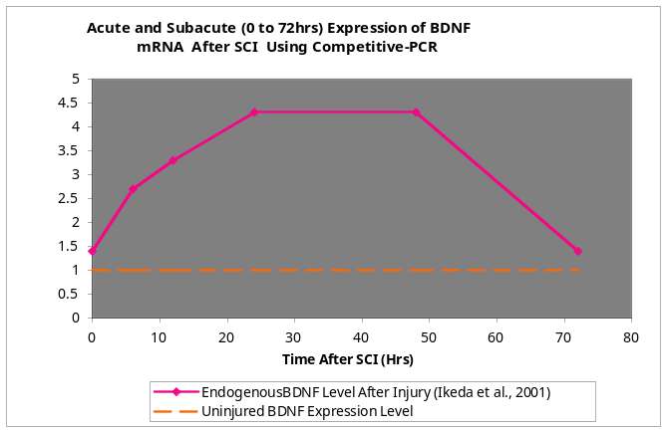
Full-length TrkB | (impact) moderate decrease at 6h, slight up regulation at 12h, continued decrease at 24h through 48h | 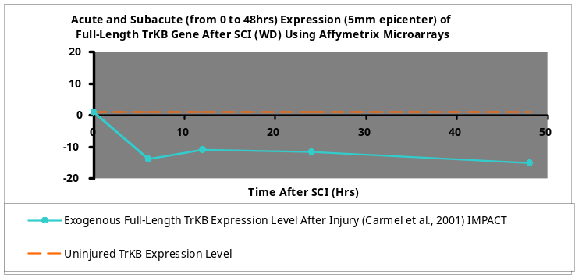
GDNF | upreg at 3hrs and peaks at 8hrs and declines to below cont. levels at 24hrs and continues to decline at 48hrs | 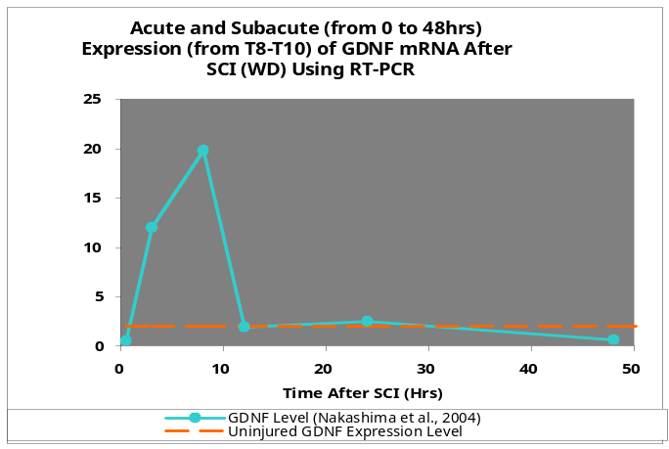
GAP-43 | (I) increase immediately observed at injury time, slight decrease by 6 hrs followed by an increase at 12hrs, by 24hrs expression is significantly increased followed by a insignificant decrease by 48hrs (DI) increase immediately at injury time, slight decrease by 6hrs followed by an increased at 12hrs which remained constant for 24hrs, significant increased observed at 48hrs | 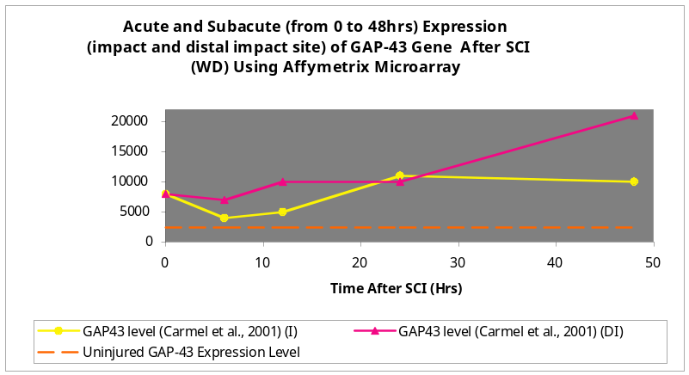
p75^{NTR} | signif increase at 12h with very slight decrease at 1d, signif increase at 3d | 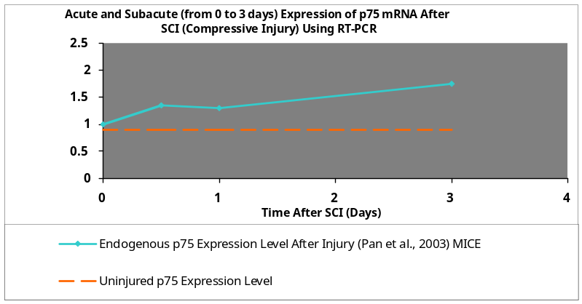
GFAP | (caudal) up-regulated 24h-3d | 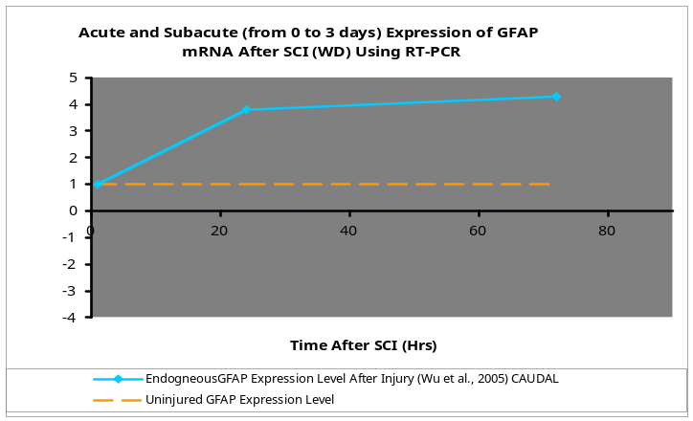
MAG | no change in expression at 12hr | 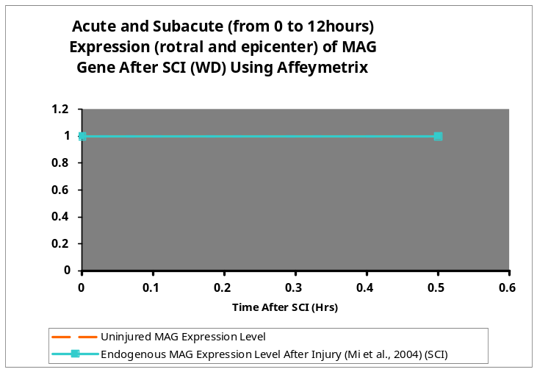
LINGO-1 | levels insignificantly slightly decrease by day 5 | 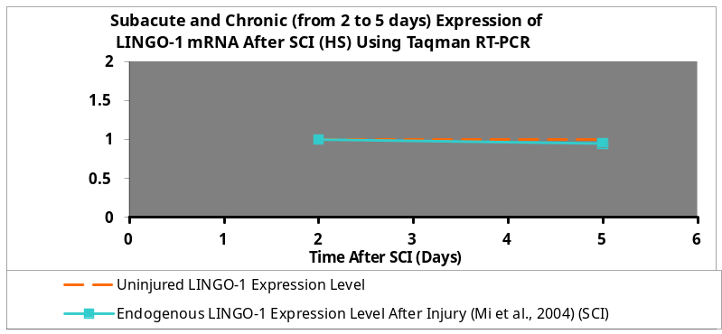
mGluR2 | immediate slight decrease at 1h followed by a signif decrease at 24h, followed by a gradual decrease at 3d | 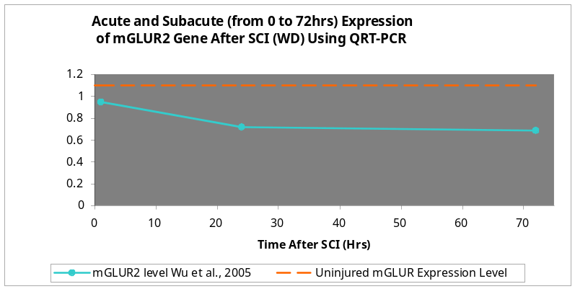
Table 2: Graphical representations of acute gene regulation for neuro-regenerative and -degenerative genes from the gene analysis investigations in table 1.

SCI Genes | Gene Response to Injury | Graphical Representation of Chronic Gene Regulation
BDNF | At one and two weeks, expression levels are higher than controls but by four weeks, expression was lower than controls | 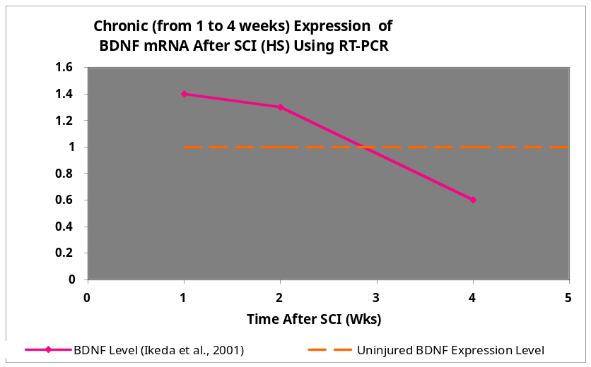
GDNF | expression continues to decline from 2w to 4w, chronic expression is well below controls | 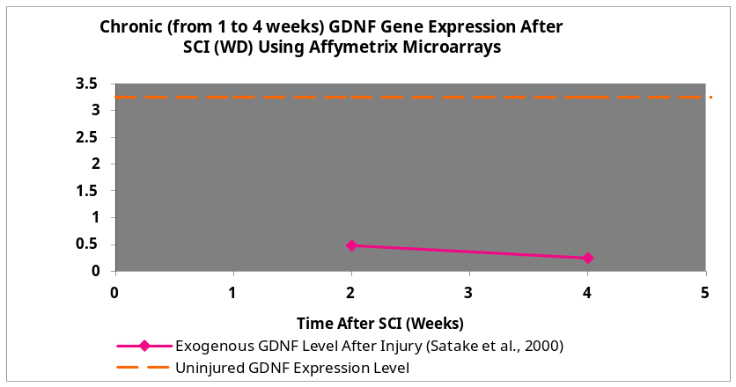
p75^{NTR} | significant increase at 3d followed by significant decrease by1w but not to control levels | 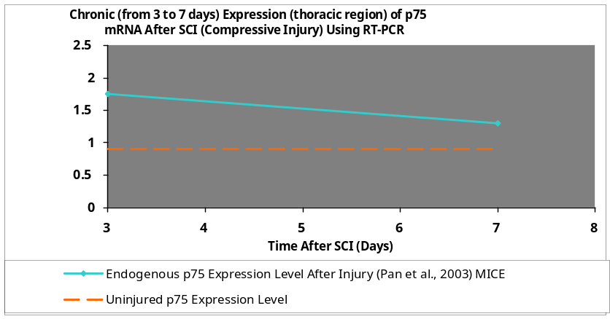
GFAP | Expression is significantly higher than controls at three days followed by a significant decrease by seven days but expression is still above uninjured levels | 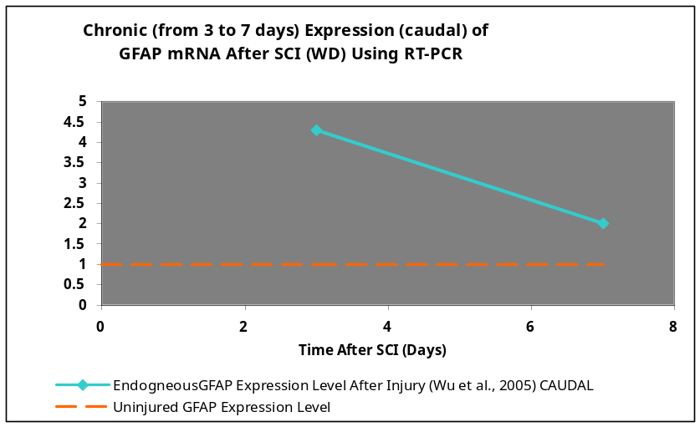
MAG | (epicenter) by 42 days, expression levels decrease to below controls; (rostral) largest decrease in expression observed, expression is below controls and epicenter | 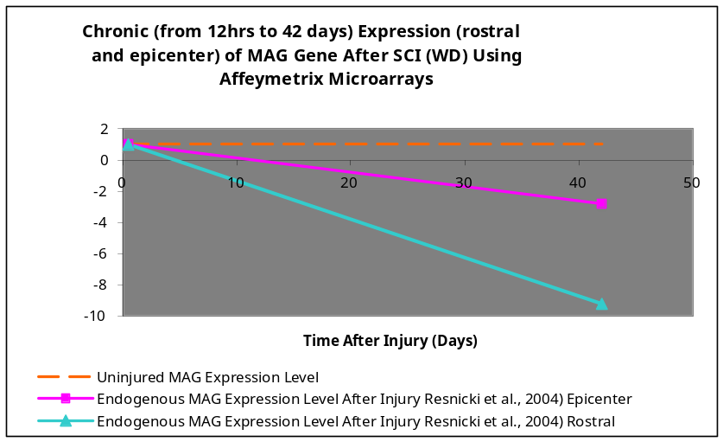
LINGO-1 | From five to seven days, expression continually rises but by 14 days, expression is dramatically increased | 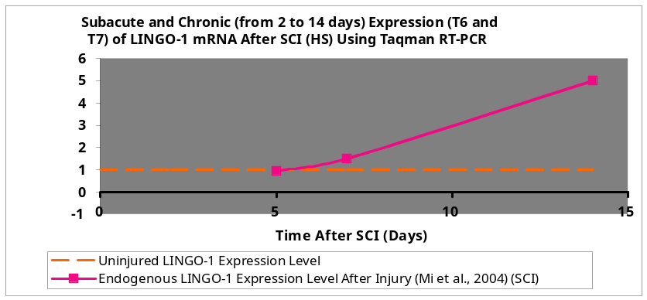
mGluR2 | By three days, expression is well below controls but by seven days expression is returning to control levels, however, expression does not reach controls by seven days | 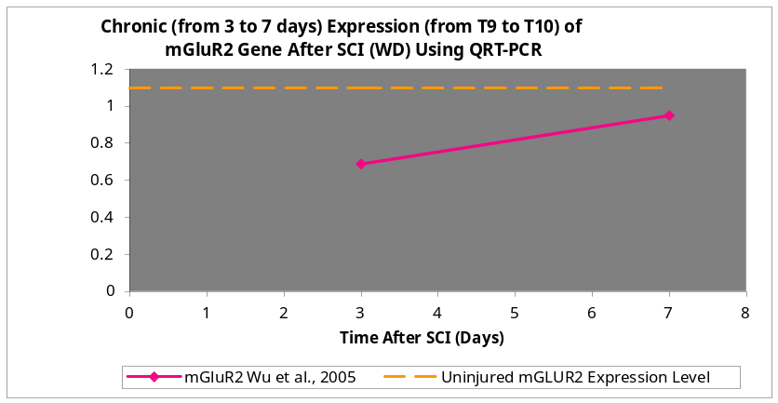
Table 2: Graphical representations of acute gene regulation for neuro-regenerative and -degenerative genes from the gene analysis investigations in table 1.

Gene Name | Drug Name | Pharmacological Drug Dosage/ Model | Time/ Method of Administration | Time of Drug Analysis/ Drug Effect | References
BDNF | BDNF (Sigma-Aldrich, St. Louis, MO) | 0.5µg to 1µg/ µL/ SCI/ section of right dorsal horn | 30min/ topical application (local) | 5 hours/ reduced cell injury and edema formation, improved motor function | Sharma et al., 2006 Acta Neurochir pgs 329-334
BDNF | AxCABDNF | 5x10⁸ pfu/mL/ SCI/complete transection | Immediately after transection/ injection or rostral and caudal stumps | Significant recovery of hindlimb function | Koda et al., 2004 J. Neurotrauma 21 pgs 329-337
Full-length TrkB | Clone29D7 mAb | 1 and 3µg/ml/ Cell culture | Cells incubated for 30min | No BDNF binding interference, increased neurite outgrowth and branching, increased acute protection and cell survival | Qian et al., 2006 J. Neurosci 26 (37) pgs 9394-9403
GDNF | GDNF (Sigma-Aldrich, St. Louis, MO) | 0.5µg to 1µg/ µL/ SCI/ section of right dorsal horn | 30min/ topical application (local) | 5 hours/ reduced cell injury and edema formation, improved motor function | Sharma et al., 2006 Acta Neurochir pgs 329-334
GDNF | rAd-GDNF | 1x10⁸pfu/µL/animal/SCI/ weight-drop | 30min/ injection in rostral area | GDNF expression for at least 8days, improved locomotor function, increased neuronal survival and protection | Tai et al., 2003 Exp. Neurol pgs 508-515
GAP-43
p75^{NTR} | LM11A-24 | 250pM/ cell culture | after MN were already exposed to <50nM nitric oxide and NGF | prevented p75^{NTR} induced cellular apoptosis | Pehar et al., 2006 J. Neurosci 24 pgs 1575-1580
GFAP  (cell proliferation) | Olomoucine dissolved in 2% DMSO in dH₂O (1mg/mL)  (Alexis, Gruenburg, Germany) | 3mg/kg/day/ SCI/ T12hemi | 1hr to 7days/ intraperitonealy injection | Suppresses neuronal cell death and astrogilal proliferation; reduces CSPGs, cavity and scar formation, enhances GAP-43 expression | Tian et al., 2006 j. Neurosci Res 84 pgs 1053-1063
MAG | Anti-MAG (Chemicon, Hampshire, UK additional prep Irving et al., 2005) | 0.12µg/h / moderate lateral fluid percussion brain injury | 1hr through 72 hours/ intracerebroventricular injection | Significant motor function improvement | Thompson et al., 2006 J. Neurosci 24 pgs 3063-3072
LINGO-1 | LINGO-1-Fc | 25µM at 0.25µL/hr / lateral right SC hemisection | Every 8 to 12 hours for 3days/ osmotic pump at T7 | Decrease RhoA activation, improved functional recovery, enhances plasticity, reduced death of oligodendrocytes and neurons | Ji et al., 2006 Mol Cell Neurosci pgs 311-320
mGluR2 | AIDA | 0.1nmol/ weight drop | 0.4µL every min for 5min/ 30-guage needle coupled to a syringe pump | Reduced glutamate levels at 15min | Mills et al., 2000 NeuroReport pgs 3067-3070
Table3: Tabular representation of treatments that have been shown to elicit and support neuronal survival and regeneration.

References

- Barton, W. A., Liu, B. P., Tzvetkova, D., Jeffrey, P. D., Fournier, A. E., Sah, D., et al. (2003). Structure and axon outgrowth inhibitor binding of the nogo-66 receptor and related proteins. [Electronic version]. The EMBO journal, 22(13), 3291-3302.

- Carmel, J. B., Galante, A., Soteropoulos, P., Tolias, P., Recce, M., Young, W., et al. (2001). Gene expression profiling of acute spinal cord injury reveals spreading inflammatory signals and neuron loss. [Electronic version]. Physiological genomics, 7(2), 201-213.

- Cassina, P., Pehar, M., Vargas, M. R., Castellanos, R., Barbeito, A. G., Estevez, A. G., et al. (2005). Astrocyte activation by fibroblast growth factor-1 and motor neuron apoptosis: Implications for amyotrophic lateral sclerosis. [Electronic version]. Journal of neurochemistry, 93(1), 38-46.

- Cassina, P., Peluffo, H., Pehar, M., Martinez-Palma, L., Ressia, A., Beckman, J. S., et al. (2002). Peroxynitrite triggers a phenotypic transformation in spinal cord astrocytes that induces motor neuron apoptosis. [Electronic version]. Journal of neuroscience research, 67(1), 21-29.

- Chen, Q. (2000). Molecular basis of behavioral recovery following spinal cord decompression: An immunocytochemical study. [Electronic version]. Chinese medical journal, 113(8), 737-742.

- Cheng, H., Wu, J. P., & Tzeng, S. F. (2002). Neuroprotection of glial cell line-derived neurotrophic factor in damaged spinal cords following contusive injury. [Electronic version]. Journal of neuroscience research, 69(3), 397-405.

- Choi, C. R., Lee, G., Lee, S. C., & Song, J. (1988). The effects of acupuncture on the sensory evoked potential response. [Electronic version]. Neurochirurgia, 31(1), 21-24.

- Dittrich, F., Ochs, G., Grosse-Wilde, A., Berweiler, U., Yan, Q., Miller, J. A., et al. (1996). Pharmacokinetics of intrathecally applied BDNF and effects on spinal motoneurons. [Electronic version]. Experimental neurology, 141(2), 225-239.

- Domeniconi, M., Cao, Z., Spencer, T., Sivasankaran, R., Wang, K., Nikulina, E., et al. (2002). Myelin-associated glycoprotein interacts with the Nogo66 receptor to inhibit neurite outgrowth. [Electronic version]. Neuron, 35(2), 283-290.

- Fehlings, M. G., & Tetzlaff, W. (2001). Summary statement: Repair of the injured spinal cord. [Electronic version]. Spine, 26(24 Suppl), S23.

- Fournier, A. E., GrandPre, T., & Strittmatter, S. M. (2001). Identification of a receptor mediating nogo-66 inhibition of axonal regeneration. [Electronic version]. Nature, 409(6818), 341-346.

- Gerin, C. (2002). Behavioral improvement and dopamine release in a parkinsonian rat model. [Electronic version]. Neuroscience letters, 330(1), 5-8.

- GrandPre, T., Nakamura, F., Vartanian, T., & Strittmatter, S. M. (2000). Identification of the nogo inhibitor of axon regeneration as a reticulon protein. [Electronic version]. Nature, 403(6768), 439-444.

- Hiebert, G. W., Khodarahmi, K., McGraw, J., Steeves, J. D., & Tetzlaff, W. (2002). Brain-derived neurotrophic factor applied to the motor cortex promotes sprouting of corticospinal fibers but not regeneration into a peripheral nerve transplant. [Electronic version]. Journal of neuroscience research, 69(2), 160-168.

- Hunt, D., Coffin, R. S., & Anderson, P. N. (2002). The nogo receptor, its ligands and axonal regeneration in the spinal cord; a review. [Electronic version]. Journal of neurocytology, 31(2), 93-120.

- Iannotti, C., Li, H., Yan, P., Lu, X., Wirthlin, L., & Xu, X. M. (2003). Glial cell line-derived neurotrophic factor-enriched bridging transplants promote propriospinal axonal regeneration and enhance myelination after spinal cord injury. [Electronic version]. Experimental neurology, 183(2), 379-393.

- Ikeda, O., Murakami, M., Ino, H., Yamazaki, M., Koda, M., Nakayama, C., et al. (2002). Effects of brain-derived neurotrophic factor (BDNF) on compression-induced spinal cord injury: BDNF attenuates down-regulation of superoxide dismutase expression and promotes up-regulation of myelin basic protein expression. [Electronic version]. Journal of neuropathology and experimental neurology, 61(2), 142-153.

- Ikeda, O., Murakami, M., Ino, H., Yamazaki, M., Nemoto, T., Koda, M., et al. (2001). Acute up-regulation of brain-derived neurotrophic factor expression resulting from experimentally induced injury in the rat spinal cord. [Electronic version]. Acta Neuropathologica, 102(3), 239-245.

- Jakeman, L. B., Wei, P., Guan, Z., & Stokes, B. T. (1998). Brain-derived neurotrophic factor stimulates hindlimb stepping and sprouting of cholinergic fibers after spinal cord injury. [Electronic version]. Experimental neurology, 154(1), 170-184.

- Ji, B., Li, M., Wu, W. T., Yick, L. W., Lee, X., Shao, Z., et al. (2006). LINGO-1 antagonist promotes functional recovery and axonal sprouting after spinal cord injury. [Electronic version]. Molecular and cellular neurosciences, 33(3), 311-320.

- Kloos, A. D., Fisher, L. C., Detloff, M. R., Hassenzahl, D. L., & Basso, D. M. (2005). Stepwise motor and all-or-none sensory recovery is associated with nonlinear sparing after incremental spinal cord injury in rats. [Electronic version]. Experimental neurology, 191(2), 251-265.

- Kobayashi, N. R., Fan, D. P., Giehl, K. M., Bedard, A. M., Wiegand, S. J., & Tetzlaff, W. (1997). BDNF and NT-4/5 prevent atrophy of rat rubrospinal neurons after cervical axotomy, stimulate GAP-43 and Talpha1-tubulin mRNA expression, and promote axonal regeneration. [Electronic version]. The Journal of neuroscience : the official journal of the Society for Neuroscience, 17(24), 9583-9595.

- Koda, M., Hashimoto, M., Murakami, M., Yoshinaga, K., Ikeda, O., Yamazaki, M., et al. (2004). Adenovirus vector-mediated in vivo gene transfer of brain-derived neurotrophic factor (BDNF) promotes rubrospinal axonal regeneration and functional recovery after complete transection of the adult rat spinal cord. [Electronic version]. Journal of neurotrauma, 21(3), 329-337.

- Liebl, D. J., Huang, W., Young, W., & Parada, L. F. (2001). Regulation of trk receptors following contusion of the rat spinal cord. [Electronic version]. Experimental neurology, 167(1), 15-26.

- Lipton, S. A., & Rosenberg, P. A. (1994). Excitatory amino acids as a final common pathway for neurologic disorders. [Electronic version]. The New England journal of medicine, 330(9), 613-622.

- Liu, B. P., Fournier, A., GrandPre, T., & Strittmatter, S. M. (2002). Myelin-associated glycoprotein as a functional ligand for the nogo-66 receptor. [Electronic version]. Science (New York, N.Y.), 297(5584), 1190-1193.

- McKerracher, L., David, S., Jackson, D. L., Kottis, V., Dunn, R. J., & Braun, P. E. (1994). Identification of myelin-associated glycoprotein as a major myelin-derived inhibitor of neurite growth. [Electronic version]. Neuron, 13(4), 805-811.

- Mi, S., Lee, X., Shao, Z., Thill, G., Ji, B., Relton, J., et al. (2004). LINGO-1 is a component of the nogo-66 receptor/p75 signaling complex. [Electronic version]. Nature neuroscience, 7(3), 221-228.

- Mills, C. D., Xu, G. Y., Johnson, K. M., McAdoo, D. J., & Hulsebosch, C. E. (2000). AIDA reduces glutamate release and attenuates mechanical allodynia after spinal cord injury. [Electronic version]. Neuroreport, 11(14), 3067-3070.

- Murray, M., & Fischer, I. (2001). Transplantation and gene therapy: Combined approaches for repair of spinal cord injury. [Electronic version]. The Neuroscientist : a review journal bringing neurobiology, neurology and psychiatry, 7(1), 28-41.

- Nakamura, M., & Bregman, B. S. (2001). Differences in neurotrophic factor gene expression profiles between neonate and adult rat spinal cord after injury. [Electronic version]. Experimental neurology, 169(2), 407-415.

- Nakashima, S., Matsuyama, Y., Yu, Y., Kiuchi, K., & Ishiguro, N. (2004). Suppression of GDNF production by MPSS treatment following spinal cord injury in the rat. [Electronic version]. Neuroreport, 15(15), 2337-2340.

- Opalenik, S. R., Ding, Q., Mallery, S. R., & Thompson, J. A. (1998). Glutathione depletion associated with the HIV-1 TAT protein mediates the extracellular appearance of acidic fibroblast growth factor. [Electronic version]. Archives of Biochemistry and Biophysics, 351(1), 17-26.

- Pan, W., Csernus, B., & Kastin, A. J. (2003). Upregulation of p55 and p75 receptors mediating TNF-alpha transport across the injured blood-spinal cord barrier. [Electronic version]. Journal of molecular neuroscience : MN, 21(2), 173-184.

- Pehar, M., Cassina, P., Vargas, M. R., Castellanos, R., Viera, L., Beckman, J. S., et al. (2004). Astrocytic production of nerve growth factor in motor neuron apoptosis: Implications for amyotrophic lateral sclerosis. [Electronic version]. Journal of neurochemistry, 89(2), 464-473.

- Pehar, M., Cassina, P., Vargas, M. R., Xie, Y., Beckman, J. S., Massa, S. M., et al. (2006). Modulation of p75-dependent motor neuron death by a small non-peptidyl mimetic of the neurotrophin loop 1 domain. [Electronic version]. The European journal of neuroscience, 24(6), 1575-1580.

- Prinjha, R., Moore, S. E., Vinson, M., Blake, S., Morrow, R., Christie, G., et al. (2000). Inhibitor of neurite outgrowth in humans. [Electronic version]. Nature, 403(6768), 383-384.

- Qian, M. D., Zhang, J., Tan, X. Y., Wood, A., Gill, D., & Cho, S. (2006). Novel agonist monoclonal antibodies activate TrkB receptors and demonstrate potent neurotrophic activities. [Electronic version]. The Journal of neuroscience : the official journal of the Society for Neuroscience, 26(37), 9394-9403.

- Resnick, D. K., Schmitt, C., Miranpuri, G. S., Dhodda, V. K., Isaacson, J., & Vemuganti, R. (2004). Molecular evidence of repair and plasticity following spinal cord injury. [Electronic version]. Neuroreport, 15(5), 837-839.

- Satake, K., Matsuyama, Y., Kamiya, M., Kawakami, H., Iwata, H., Adachi, K., et al. (2000). Up-regulation of glial cell line-derived neurotrophic factor (GDNF) following traumatic spinal cord injury. [Electronic version]. Neuroreport, 11(17), 3877-3881.

- Schwab, M. E. (2002). Repairing the injured spinal cord. [Electronic version]. Science (New York, N.Y.), 295(5557), 1029-1031.

- Sharma, H. S. (2006). Post-traumatic application of brain-derived neurotrophic factor and glia-derived neurotrophic factor on the rat spinal cord enhances neuroprotection and improves motor function. [Electronic version]. Acta neurochirurgica.Supplement, 96, 329-334.

- Tai, M. H., Cheng, H., Wu, J. P., Liu, Y. L., Lin, P. R., Kuo, J. S., et al. (2003). Gene transfer of glial cell line-derived neurotrophic factor promotes functional recovery following spinal cord contusion. [Electronic version]. Experimental neurology, 183(2), 508-515.

- Thompson, H. J., Marklund, N., LeBold, D. G., Morales, D. M., Keck, C. A., Vinson, M., et al. (2006). Tissue sparing and functional recovery following experimental traumatic brain injury is provided by treatment with an anti-myelin-associated glycoprotein antibody. [Electronic version]. The European journal of neuroscience, 24(11), 3063-3072.

- Wang, X., Chun, S. J., Treloar, H., Vartanian, T., Greer, C. A., & Strittmatter, S. M. (2002). Localization of nogo-A and nogo-66 receptor proteins at sites of axon-myelin and synaptic contact. [Electronic version]. The Journal of neuroscience : the official journal of the Society for Neuroscience, 22(13), 5505-5515.

- Weinmann, O., Schnell, L., Ghosh, A., Montani, L., Wiessner, C., Wannier, T., et al. (2006). Intrathecally infused antibodies against nogo-A penetrate the CNS and downregulate the endogenous neurite growth inhibitor nogo-A. [Electronic version]. Molecular and cellular neurosciences, 32(1-2), 161-173.

- Wong, S. T., Henley, J. R., Kanning, K. C., Huang, K. H., Bothwell, M., & Poo, M. M. (2002). A p75(NTR) and nogo receptor complex mediates repulsive signaling by myelin-associated glycoprotein. [Electronic version]. Nature neuroscience, 5(12), 1302-1308.

- Wu, X., Yoo, S., & Wrathall, J. R. (2005). Real-time quantitative PCR analysis of temporal-spatial alterations in gene expression after spinal cord contusion. [Electronic version]. Journal of neurochemistry, 93(4), 943-952.

- Xu, G. Y., Hughes, M. G., Ye, Z., Hulsebosch, C. E., & McAdoo, D. J. (2004). Concentrations of glutamate released following spinal cord injury kill oligodendrocytes in the spinal cord. [Electronic version]. Experimental neurology, 187(2), 329-336.

- Yamashita, T., Higuchi, H., & Tohyama, M. (2002). The p75 receptor transduces the signal from myelin-associated glycoprotein to rho. [Electronic version]. The Journal of cell biology, 157(4), 565-570.

- Yamashita, T., Tucker, K. L., & Barde, Y. A. (1999). Neurotrophin binding to the p75 receptor modulates rho activity and axonal outgrowth. [Electronic version]. Neuron, 24(3), 585-593.

Inject LM11A-24 (250pM) to Caudal Region
Intraperitoneal Injection of Olomoucine (3mg/kg/day)
(0.75mg/kg/8hrs) in Caudal Region
Intraperitoneal Injection of Olomoucine (3mg/kg/day)
(0.75mg/kg/8hrs) in Caudal Region
Intraperitoneal Injection of Olomoucine (3mg/kg/day)
(0.75mg/kg/8hrs) in Caudal Region
Intraperitoneal Injection of Olomoucine (3mg/kg/day)
(0.75mg/kg/8hrs) in Caudal Region
Intrathecally Deliver Nogo-A Abº 11C7 (3mg/mL/7days) (0.018mg/mL/hr)in Caudal Region
FINAL Intrathecal Delivery of LINGO-1-Fc (2µg/µL/8hrs) (0.25µL/hr) to Caudal Region

Topically Deliver 29D7 Ab (1µg/mL/day)
(0.20µg/mL/6hrs) to Caudal Region
FINAL Topical Delivery 29D7 Ab (1µg/mL/day)
(0.20µg/mL/6hrs) to Caudal Region

Topically Deliver 29D7 Ab (1µg/mL/day)
(0.20µg/mL/6hrs) to Caudal Region
Intrathecally Inject anti-MAG (2.88µg/µL/day) (0.12µg/µL/hr) in Caudal Region

Intrathecal Delivery of LINGO-1-Fc (2µg/µL/8hrs) (0.25µL/hr) to Caudal Region
Topically Deliver BDNF (0.5µg/µL/day)
(0.021µg/µL/hr) and GDNF (0.03125µg/µL/hr)
to Caudal Region
SINGLE Injection of AIDA (0.05mM soln) (0.4µL/min for 5 min) in Caudal Region

14hrs
12hrs
10hrs
8hrs
6hrs
4hrs
2hrs
0hrs
24hrs
22hrs
20hrs
18hrs
16hrs
Topically Deliver 29D7 Ab (1µg/mL/day)
(0.20µg/mL/6hrs) to Caudal Region
Topically Deliver 29D7 Ab (1µg/mL/day)
(0.20µg/mL/6hrs) to Caudal Region

SINGLE BDNF Treatment Course Inject viral vector encoding GDNF (5x10³ pfu/mL) in Caudal Region

SINGLE GDNF Treatment Inject viral vector encoding GDNF (1x10³ pfu/µL) in Caudal Region

Intraperitoneal Injection of Olomoucine (3mg/kg/day)
(0.75mg/kg/8hrs) in Caudal Region

Topically Deliver LM11A-24 (250pM) to Caudal Region
Intraperitoneal Injection of Olomoucine (3mg/kg/day)
(0.75mg/kg/8hrs) in Caudal Region
Intraperitoneal Injection of Olomoucine (3mg/kg/day)
(0.75mg/kg/8hrs) in Caudal Region
Intraperitoneal Injection of Olomoucine (3mg/kg/day)
(0.75mg/kg/8hrs) in Caudal Region
Intrathecally Deliver Nogo-A Abº 11C7 (3mg/mL/7days) (0.018mg/mL/hr)in Caudal Region

Intrathecally Inject anti-MAG (2.88µg/µL/day) (0.12µg/µL/hr) in Caudal Region

Topically Deliver BDNF (0.5µg/µL/day)
(0.021µg/µL/hr) and GDNF (0.03125µg/µL/hr)
to Caudal Region

40hrs
38hrs
36hrs
34hrs
32hrs
30hrs
26hrs
50hrs
48hrs
46hrs
44hrs
42hrs

28hrs

Intraperitoneal Injection of Olomoucine (3mg/kg/day)
(0.75mg/kg/8hrs) in Caudal Region

FINAL Topically Deliver LM11A-24 (250pM) to Caudal Region
Intraperitoneal Injection of Olomoucine (3mg/kg/day)
(0.75mg/kg/8hrs) in Caudal Region
FINAL Intraperitoneal Injection of Olomoucine (3mg/kg/day)
(0.75mg/kg/8hrs) in Caudal Region
Intrathecally Deliver Nogo-A Abº 11C7 (3mg/mL/7days) (0.018mg/mL/hr)in Caudal Region

Intrathecally Inject anti-MAG (2.88µg/µL/day) (0.12µg/µL/hr) in Caudal Region
FINAL Topically Delivery BDNF (0.5µg/µL/day)
(0.021µg/µL/hr) and GDNF (0.03125µg/µL/hr)
to Caudal Region

FINAL Intrathecal Inject anti-MAG (2.88µg/µL/day) (0.12µg/µL/hr) in Caudal Region
Topically Deliver BDNF (0.5µg/µL/day)
(0.021µg/µL/hr) and GDNF (0.03125µg/µL/hr)
to Caudal Region

66hrs
64hrs
62hrs
60hrs
58hrs
56hrs
52hrs
72hrs
70hrs
68hrs

54hrs

Re-Initiate Nogo-A Treatment Course Intrathecally Deliver Nogo-A Abº 11C7 (3mg/mL/7days) (0.018mg/mL/hr)in Caudal Region

Re-Initiate Nogo-A Treatment Course Intrathecally Deliver Nogo-A Abº 11C7 (3mg/mL/7days) (0.018mg/mL/hr)in Caudal Region

Intrathecal Delivery of LINGO-1-Fc (2µg/µL/8hrs) (0.25µL/hr) to Caudal Region

10days
8days
12days
14days
16days

11days
9days
13days
15days
7days
6days
5days
4days
FINAL Intrathecally Delivery Nogo-A Abº 11C7 (3mg/mL/7days) (0.018mg/mL/hr)in Caudal Region
Re-Initiate GDNF Treatment Course Inject viral vector encoding GDNF (1x10³ pfu/µL) in Caudal Region
Re-Initiate BDNF Treatment Course Inject viral vector encoding BDNF (1x10³ pfu/µL) in Caudal Region

Re-Initiate BDNF Treatment Course Inject viral vector encoding BDNF (1x10³ pfu/µL) in Caudal Region
Re-Initiate GDNF Treatment Course Inject viral vector encoding GDNF (1x10³ pfu/µL) in Caudal Region

26days
22days
18days
30days

24days
20days
28days

Re-Initiate GDNF Treatment Course Inject viral vector encoding GDNF (1x10³ pfu/µL) in Caudal Region

Re-Initiate Nogo-A Treatment Course Intrathecally Deliver Nogo-A Abº 11C7 (3mg/mL/7days) (0.018mg/mL/hr)in Caudal Region

